

**Ecosystem Extent Accounts 2000 - 2018**

**– A European Analysis**

EEA technical report produced as part of the EU project on Integrated Natural Capital Accounting (KIP INCA)

Version 1.0 – February 2021

**Authors:**

Jan-Erik Petersen (EEA), Daniel Desaulty (EEA), Eva Ivits (EEA), Emanuele Mancosu (ETC/ULS), Roger Milego (ETC/ULS) & Steven King (WCMC)

Table of Contents

Glossary 5

Executive summary 7

1 Introduction 9

2 Methodology 11

2.1 Three-Tier Approach 11

2.1.1 Detailed Tier I to III typology 12

2.1.2 Linking the EEA three-tier approach to the IUCN Global Ecosystem Typology 15

2.2 Data foundation and set-up of geo-spatial database for ecosystem accounting 16

2.3 Accounting Items 18

2.4 Uncertainty 18

2.5 Ecosystem Accounting Areas (Geographical Aggregations) 19

3 Tier I European Ecosystem Extent Accounts 20

3.1 Tier I Ecosystem Extent Accounts (EEA-38 + UK) 21

3.2 Tier I Ecosystem Extent Accounts (EU-27 + UK) 27

3.3 Tier I Ecosystem Extent Accounts by biogeographical region (EEA-38 + UK) 33

4 Analysing Tier 1 Ecosystem Extent Accounts for ecosystem types and accounting areas of policy interest 41

4.1 Urbanisation (EEA-38 + UK) 42

4.2 Ecosystem extent inside and outside Natura 2000 sites (EU-27 + UK) 47

5 Tier II Ecosystem Extent Trends and Accounts 56

5.1 Tier II Ecosystem Extent Accounts for natural and semi-natural MAES ecosystems (EEA-38 + UK) 58

5.2 Tier II Ecosystem Extent Accounts for forest ecosystems (EEA-38 + UK) 61

6 Tier III Ecosystem Extent Accounts (EEA-38 + UK) 63

7 Synthesis of results 66

7.1 Analysis of Ecosystem Extent in Europe (EEA-38 + UK and EU-27 + UK) 66

7.2 Analysis of Ecosystem Extent by Biogeographical Region (EEA-38 + UK) 68

7.3 Other Policy applications 68

8 Review and outlook 70

8.1 Review of current work and analytical options 70

8.2 Outlook 71

References 72

Annex 1 MAES typology of ecosystems considered in Tier I Ecosystem Extent Accounts (MAES, 2013) 75

Annex 2 EEA ecosystem extent accounts – description of tiered approach 76

Annex 3 Tier I Ecosystem Extent Accounts per EEA Member Country 79

List of Figures

Figure 1‑1: The SEEA EEA system of ecosystem accounts. SNA stands for system of national accounts. 9

Figure 2‑1: Stylised presentation of the new proposal for Tier I to III Ecosystem Extent Accounts in Europe. The dashed line (*) disaggregating some Tier III classes reflects that further work is required to establish how much subdivision will be possible using HRL and biodiversity monitoring data. 12

Figure 2‑2: Organisation of the EEA integrated data platform (IDP). Source: ETC/ULS report 02/2020 Land and ecosystem accounts for Europe, Towards geospatial environmental accounting. 16

Figure 3‑1: Tier I ecosystem extent and relative change, EEA-38 + UK countries, 2000 – 2018. 25

Figure 3‑2: Tier I ecosystem extent and relative change, EU-27 + UK countries, 2000 – 2018. 32

Figure 3‑3: Percentage of MAES ecosystem type per biogeographic region, 2018. 35

Figure 4‑1: Percentage of MAES ecosystem type for area inside Natura 2000 network, EU-27 + UK countries, 2018. 53

Figure 4‑2: Percentage of MAES ecosystem type for area outside Natura 2000 network, EU-27 + UK countries, 2018. 54

Figure 4‑3: Net changes in ecosystem extent for areas inside and outside Natura 2000 network, EU-27 + UK countries, 2000 – 2018. 55

Figure 5‑1: Tier II ecosystem extent, EEA-38 + UK countries, 2018. 56

Figure 5‑2: Change in Forest and woodland extent by CLC Level 3, EEA-38 + UK countries, 2000 – 2018. 61

Figure 7‑1: Overall trends for semi-natural Tier II and III ecosystem types, EEA-38 + UK countries, 2000 – 2018. 67

List of Tables

Table 2.1: Detailed Tier I to III Ecosystem Extent Accounts typology for Europe. 13

Table 2.2: Uncertainty thresholds for changes in ecosystem extent for European analysis. 19

Table 3.1: Tier I Ecosystem Extent Account, EEA-38 + UK countries, 2000 – 2006. 22

Table 3.2: Tier I Ecosystem Extent Account, EEA-38 + UK countries, 2006 – 2012. 23

Table 3.3: Tier I Ecosystem Extent Account, EEA-38 + UK countries, 2012 – 2018. 24

Table 3.4: Tier I Ecosystem Extent Account, EU-27 + UK countries, 2000 – 2006. 29

Table 3.5: Tier I Ecosystem Extent Account, EU-27 + UK countries, 2006 – 2012. 30

Table 3.6: Tier I Ecosystem Extent Account, EU-27 + UK countries, 2012 – 2018. 31

Table 3.7: Tier I Ecosystem Extent Accounts by biogeographical region, EEA-38 + UK countries, 2000 – 2018. 37

Table 4.1: Gross Urban ecosystem increase by MAES type for EEA-38 + UK countries, 2000 – 2018. 44

Table 4.2: Tier I Ecosystem Extent Account for Natura 2000 network, EU-27 + UK countries, 2000 - 2006. 48

Table 4.3: Tier I Ecosystem Extent Account for Natura 2000 network, EU-27 + UK countries, 2006 - 2012. 48

Table 4.4: Tier I Ecosystem Extent Account for Natura 2000 network, EU-27 + UK countries, 2012 - 2018. 49

Table 4.5: Tier I Ecosystem Extent Account for area outside Natura 2000 network, EU-27 + UK countries, 2000 - 2006. 51

Table 4.6: Tier I Ecosystem Extent Account for area outside Natura 2000 network, EU-27 + UK countries, 2006 - 2012. 51

Table 4.7: Tier I Ecosystem Extent Account for area outside Natura 2000 network, EU-27 + UK countries, 2012 - 2018. 52

Table 5.1: Tier II ecosystem extent trends for natural and semi-natural CLC Classes by MAES ecosystem type, EEA-38 + UK countries, 2000 – 2018. 60

Table 6.1: Tier III Ecosystem Extent Accounts, EEA-38 + UK countries, 2000 – 2018. 64

List of Maps

Map 3‑1: Biogeographic regions in Europe. 34

Map 4‑1: Natura 2000 coverage, EU-27 + UK countries, 2018. 47

# Glossary

**Accounting Period:** This is the measurement period for the accounts. The accounts record measures of ecosystems and their services at the beginning and end of the accounting period and associated changes.

**Additions (in extent):** The gross additions to the extent of ecosystems over the accounting period.

**Closing Extent:** This is the area of an ecosystem as measured at the end of an accounting period.

**Corine Land Cover (CLC):** The EEA Land Cover Mapping product comprising of three levels of classes. Level 3 is the highest level of disaggregation, consisting of 44 different land cover classes (Kosztra et al., 2017). The reference year for CLC is 1990, with updates produced in 2000, 2006, 2012 and 2018.

**Corine Land Cover accounting layer:** A time series of CLC data sets that has been statistically aligned between its different time points to allow a coherent measurement of change detection. The reference point for this alignment is always the most recent CLC status layer.

**Corine Land Cover status layer:** The original data sets compiled during each CLC campaign (2000, 2006, 2012, 2018). They represent the best possible land cover data set for each period, reflecting the available technology and satellite imagery at that point, and have not been post-adjusted.

**Ecosystem asset:** A spatial representation of ecosystems as contiguous areas of a single ecosystem type that form the conceptual base for accounting and the integration of relevant statistics (UN et al., 2017).

**Ecosystem extent:** The area covered by an ecosystem of a given type (UN et al., 2014).

**Ecosystem condition:** The effective capacity of an ecosystem to provide services, relative to its potential capacity. In accounting parlance, the condition of an ecosystem asset based on measurements of various characteristics at a given point in time (UN et al., 2014).

**Ecosystem Accounting Area:** The geographical extent for tabulating species or ecosystem information defined by, for example, sub-region boundaries, protected areas or national boundaries (UN et al., 2017).

**Internal transformations:**These are transformations from one ecosystem type to another that occur within the same parent ecosystem type (e.g., changes from transitional woodland and shrub to mixed forest, within the parent ecosystem type of ‘Forest and woodland’).They are included in the calculations of the additions and reductions and the accounting variable ‘turnover’. Internal transformations can lead to high turnover rates in internally dynamic land cover types and MAES ecosystem types (e.g., Urban and Forest and woodlands).

**Mapping and Assessment of Ecosystems and their Services (MAES):** MAES provides an analytical framework for ecosystem assessments in the EU. It establishes a broad typology of 12 ecosystem types. The nine terrestrial ecosystem types are based on aggregations of the 44 CLC Level 3 classes (MAES, 2013).

**Reductions (in extent):** The gross reduction to the extent of ecosystems over the accounting period.

**Stable ecosystem stock:** This is the stock of the original ecosystem type that remains unchanged over the accounting period, the opening stock of a given ecosystem type minus the reductions over the accounting period (EEA, 2006a).

**System of Environmental-Economic Accounting – Experimental Ecosystem Accounting (SEEA EEA):** An experimental, multipurpose, statistical framework that aims to reinforce and quantify the importance of the relationship between people and their environment (UN et al., 2014).

**System of National Accounts (SNA):** The internationally adopted standard for compiling national statistics on economic activity.

**Turnover****(of ecosystem extent)*:***The gross change in ecosystem extent over an accounting period, the sum of the additions and reductions for an ecosystem type over the accounting period (this includes internal transformations).

# Executive summary

This report presents the first full European analysis of Ecosystem Extent Accounts, covering the period 2000 to 2018 for the 38 member and cooperating countries of the European Environment Agency and the United Kingdom (EEA-38 + UK). Results are also presented for the 27 Member States of the European Union and the United Kingdom (EU-27 + UK). It was developed by the European Environment Agency (EEA) as part of a project for developing an Integrated Natural Capital Accounting System for the European Union (KIP INCA).

The EEA proposes a three-tier approach to the development of Ecosystem Extent Accounts in Europe based on a fully nested approach and aggregations of Corine Land Cover (CLC) Level 3 classes. Tier I develops Ecosystem Extent Accounts for the 9 of the 12 broad ecosystem types developed in the Mapping and Assessment of Ecosystems and their Services (MAES) process[1] (Coastal, Shelf and Open Ocean are excluded due to data limitations for marine ecosystems). Tier II is designed to deliver a better ecological interpretation of ecosystem trends while remaining manageable in terms of scope. In Tier II, 23 ecosystem categories are proposed based on aggregations of the same 42 CLC Level 3 classes used to inform Tier 1. Tier III provides opportunity for more detailed analysis of ecosystem trends, where required. The Tier III approach is based on 32 ecosystem types, again directly aggregated from the same 42 CLC level 3 classes and fully nested within Tier II.

Overall, the Tier I Ecosystem Extent Accounts reveal that the extent of ecosystems in Europe is generally stable. Urban ecosystems show the highest increase in extent (around 6%) between 2000 and 2018. With the exception of Rivers and lakes, all other terrestrial ecosystems show a decline in extent over this period. A more detailed analysis of the CLC classes underpinning this MAES Ecosystem type reveal that the increase in Rivers and lakes ecosystems is due to an increasing area of water bodies (most likely artificial reservoirs and lakes). This analysis also shows that reductions in the extent of ecosystem type Inland wetlands are driven by loss of peat bog area. The reductions in Heathland and shrub are mainly due to the loss of the CLC class representing Sclerophyllous vegetation.

The set-up of the EEA geo-spatial database underpinning the calculation of Ecosystem Extent Accounts allows them to be calculated for many different spatial configurations depending on analytical interest. These analytical focus areas are called ‘ecosystem accounting areas’ in ecosystem accounting terminology. Ecosystem accounting areas can be of flexible size and shape, relating to administrative areas (e.g. municipalities or provinces) or bio-geographical units, such as water basins or mountain ranges. This has enabled analysis by biogeographical region, trends in Natura 2000 and allowed exploring the impacts of urbanisation and the dynamic nature of Forest and woodland ecosystems. These reveal additional insights, such as that the reduction of Heathland and shrub extent in Europe is driven by reductions in the Mediterranean biogeographical region, and the reduction of Inland wetland extent is driven by reductions in the Atlantic biogeographical region. The main ecosystem lost to urbanisation is found to be Cropland, although regional differences emerge. In particular, Forest and woodland is the main ecosystem lost to urbanisation in Nordic countries and Grassland in Ireland. Within the Natura 2000 network of protected areas, the ecosystem configuration comprises relatively less Cropland and urban extent and is also more stable, compared to the rest of the EU-27 + UK (although semi-natural ecosystems were still found to be decreasing in extent)*.*

The Tier I, Tier II and III Ecosystem Extent Accounts can provide information to support policy analysis, particularly when developed for specific geographic areas, such as water basins. This can be extended to considering the impacts on biodiversity by incorporating information on species ecosystem preferences. In addition, by associating ecosystem types with different ecosystem services insights can readily be gained on how the spatial configuration of natural capital can be improved for multiple beneficiaries (Jacobs et al., 2015). The spatial data set-up underpinning the extent accounts also provides the necessary framework for integrating SEEA EEA accounting modules, such as ecosystem condition and service accounts, which will be fundamental to achieving the spatially coherent data foundation necessary for an integrated analysis of Europe’s Natural Capital.

Further steps for the development of Ecosystem Extent Accounts for Europe could tackle:

* Integrating a wider range of ecosystem information with the Ecosystem Extent Accounts on a joint geo-spatial platform. This would enable an integrated spatial analysis of connections between different ecosystem accounting themes (e.g., extent, condition, services and themes such as biodiversity, water and carbon);
* Improving the geometric precision of underpinning land cover data, for example by using the Corine Land Cover plus (CLC+) and other high resolution land cover (HRL) datasets from the EEA’s Copernicus Land Services; and,
* Extending ecosystem accounts to include the entire marine realm associated with the Exclusive Economic Zones of EU Member States and EEA member countries.

# Introduction

The European Union (EU) set itself ambitious targets for the preservation and better management of natural capital in the 7th Environmental Action Programme of the EU and the EU Biodiversity Strategy to 2020. Natural capital accounting has emerged as an important policy support tool for achieving these and other objectives at the EU and Member State levels (EC & EEA, 2016). To build the knowledge base for achieving these objectives, a shared project was set up at the EU level to develop an integrated system for natural capital and ecosystem services accounting (KIP-INCA). KIP-INCA builds on the first phase of Action 5 of the EU Biodiversity Strategy to 2020 ‘Mapping and Assessment of Ecosystems and their Services (MAES)’, which aims to map and assess ecosystems and their services on national and European level. KIP-INCA also supported the second phase of MAES, which aimed to value ecosystem services and integrate them into accounting and reporting systems by 2020.

The project aims to develop accounts on the extent and condition of ecosystems present in the EU, as well as accounts for selected services from these ecosystems and their contribution to the economy and human well-being. The methodological frame for developing ecosystem accounts is provided by the System of Environmental-Economic Accounting Experimental Ecosystem Accounting (SEEA EEA) framework (UN et al., 2014). The SEEA EEA was developed under the auspices of the United Nations Statistics Division (UNSD), with significant input from the EU Member States and organisations. An updated methodological UN standard for ecosystem accounting (SEEA EA) will be published soon[2].

Within the SEEA EEA, ecosystems are considered physical assets that are characterised on the basis of their extent and a set of condition characteristics (stock) and their ability to deliver ecosystem services (flow). Monetary valuation of these ecosystem service flows supports the integration of ecosystem services into economic analysis and the system of national accounts. Figure 1‑1 sets out the different core bio-physical accounting modules (green) and monetary accounting modules (blue) of SEEA EEA.

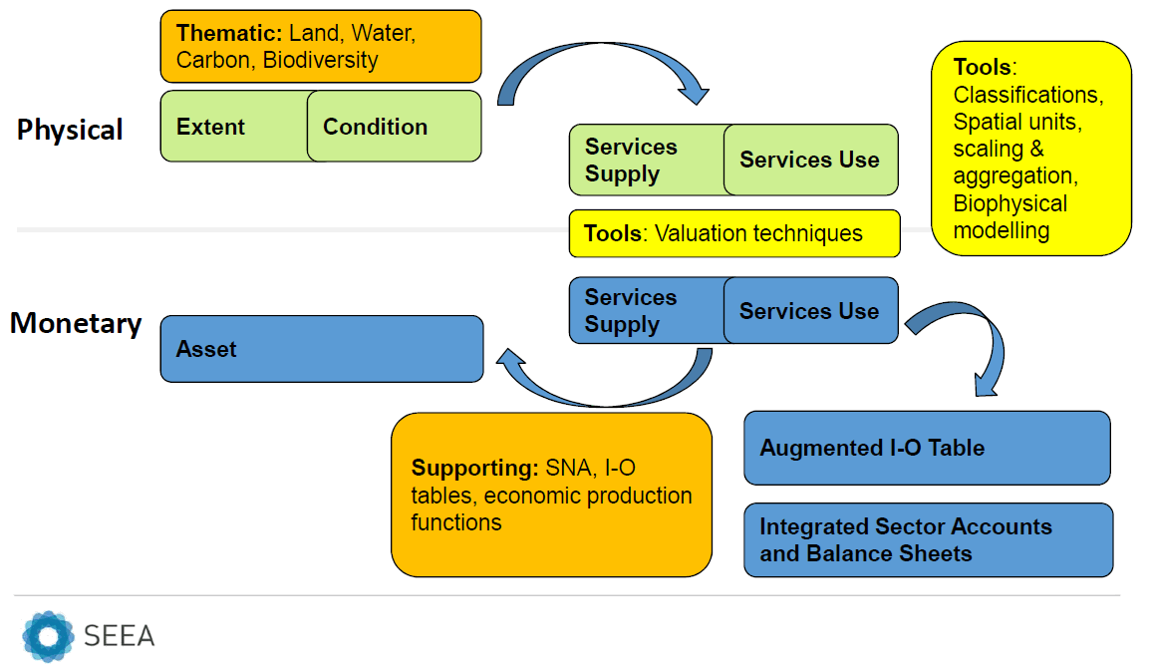

Figure ‑: The SEEA EEA system of ecosystem accounts. SNA stands for system of national accounts.

The SEEA EEA requires the delineation of different ecosystem types within an accounting area (e.g., the EU, a Member State or a Biogeographical region). The information on the extent of the different ecosystem types within this area is organised within the Ecosystem Extent Accounts (see Figure 1‑1). The aim of this account is to track the extent of different ecosystem types over time. These accounts also provide the underpinning spatial infrastructure for the compilation of other ecosystem accounting modules, such as providing the basis for the measurement of condition. In combination with Ecosystem Condition Accounts, the Ecosystem Extent Accounts are the basis for estimating potential flows of ecosystem services. This reflects that the estimation of service flows, and associated valuation, cannot be achieved without understanding the location and extent of different ecosystems within an accounting area. Accordingly, the Ecosystem Extent Accounts provide an initial understanding of how changes in the distribution of different ecosystem types may impact on ecosystem services supply in the future (UN et al., 2014). Ecosystem Extent Accounts can also provide information on policy and land development issues more directly, for example they may be used in:

* Supporting the assessment of ecosystem diversity, deforestation, urbanisation and other forms of land use driven change (UN et al., 2017);
* Accounting for the impacts of land use change on habitat for species of conservation and economic importance (UNEP-WCMC & IDEEA, 2017);
* Monitoring progress towards the CBD Aichi Targets (Vardon et al., 2017).

The work presented here describes the calculation by the EEA of the first full set of Ecosystem Extent Accounts, covering the 27 countries of the European Union and the UK (hereafter EU 27 + UK) considered under the KIP-INCA project, as well as the 38 countries that are member or cooperating countries of the European Environment Agency (EEA-38[3]). The accounts cover the period 2000 to 2018.

The remainder of this document is structured as follows:

* Chapter 2 explains a three-tier approach to compiling Ecosystem Extent Accounts in Europe;
* Chapter 3 summarises the Tier I Ecosystem Extent Accounting results for Europe;
* Chapter 4 provides an analysis of the Tier I Ecosystem Extent Accounts by ecosystem type and accounting areas of policy interest;
* Chapter 5 presents results for selected Tier II Ecosystem Extent Accounts;
* Chapter 6 presents results to selected Tier III Ecosystem Extent Accounts;
* Chapter 7 provides a synthesis of results;
* Chapter 8 reviews the current work and provides an outlook on future steps.

Annex 1 presents and describes the MAES Ecosystem Typology employed for the compilation of the Tier I Ecosystem Extent Accounts.

Annex 2 sets out the three-tier structure of the EEA Ecosystem Extent Accounts and provides a brief summary of the principles informing its development.

Annex 3 (provided as separate file) presents ecosystem accounting results for the MAES ecosystem types for the period 2000 to 2018 at the national level. It is highlighted that many statistics on the extent of Tier I to III Ecosystem Types for countries and other Ecosystem Accounting Areas are available at an EEA interactive dashboard: [Ecosystem Extent Accounts — European Environment Agency (europa.eu)](https://www.eea.europa.eu/data-and-maps/data/data-viewers/ecosystem-extent-accounts?portal_status_message=Changes%20saved.)

# Methodology

Ecosystem Extent Accounts show the opening and closing extent of different ecosystem types over an accounting period (e.g., 6 years) in a spatially explicit manner (e.g., in hectares or km2). Where Ecosystem Extent Accounts are compiled for multiple accounting periods, trends can then be tracked over time. For example, the extent of natural or semi-natural ecosystems that may be of importance for biodiversity. The Ecosystem Extent Accounts produced by the EEA aim to support the analysis of the status and change in natural capital in Europe (EEA-38 + UK and EU-27 + UK areas) with regards to ecosystem-based management, reflecting Objective 1 of the 7th Environmental Action Programme ‘to protect, conserve and enhance the Union’s natural capital’.

Calculating Ecosystem Extent Accounts requires deciding on an appropriate typology for ecosystems within an accounting area in order to allow the delineation of different ecosystem types. The SEEA EEA aims for ecosystem types to be delineated in such a way that there are no gaps in ecosystem coverage or overlaps between different types (i.e. an approach that is mutually exclusive and collectively exhaustive, the MECE principle). This reflects a standard statistical approach to classifications and requires an ecosystem typology that is both geographically and thematically exhaustive for Europe’s ecosystems.

## Three-Tier Approach

The EEA employs a three-tier approach to delineating ecosystems in Europe and build Ecosystem Extent Accounts, which is based on Corine Land Cover (CLC) data derived from satellite images. The approach is fully nested, hierarchical and in strict accordance with the MECE principle required by the SEEA EEA. The approach is implemented directly using the CLC Level 3 classes.

Tier I comprises Ecosystem Extent Accounts for the broad terrestrial, freshwater and marine transitional ecosystem types established by the MAES process (MAES, 2013). In Tier I, nine ecosystem types are delineated, namely Urban, Cropland, Grassland, Forest and woodland, Heathland and shrub, Sparsely vegetated land, Inland wetlands, Rivers and lakes, and Marine inlets and transitional waters (as described in Annex 1). These nine broad ecosystem types are based on aggregations of 42 CLC Level 3 classes (the CLC Level 3 classes, ‘Burnt Areas’ and ‘Sea and Ocean’ are not considered ecosystem types, as described in detail in Section 2.1.1). The MAES ecosystem types Coastal, Shelf and Open Ocean are not included in the Tier I extent accounts. This reflects the current lack of marine spatial data fit for ecosystem extent accounting. Nonetheless, the Tier I Ecosystem Extent Accounts cover the entire terrestrial area of the EU-27 + UK and EEA-38 + UK and the typology is non-overlapping, thus satisfying the MECE principle.

The Tier I Ecosystem Extent Accounts provide a broad representation of ecosystem trends and enable tracking major land use trends which affect ecosystem extent such as urbanisation. It is considered important to maintain the MAES ecosystem typology as the Tier I starting point, in order to ensure that ecosystem accounting in Europe can be integrated with wider ecosystem assessment and policy support work in Europe. However, more disaggregated information on ecosystems is required to provide Ecosystem Extent Accounts that deliver further ecologically meaningful insights.

Tier II is designed to deliver a better ecological interpretation of ecosystem trends in the Ecosystem Extent Accounts for Europe. It has been developed to strike a balance between ecological interpretation of ecosystem trends and remaining manageable in terms of scope (i.e., the dimensions of the accounting tables remain manageable). In Tier II, 23 ecosystem categories are proposed based on aggregations of the same 42 CLC Level 3 classes used to inform Tier 1. These 23 categories are fully nested within different MAES ecosystem types (i.e., individual MAES ecosystem types can be disaggregated to specific, individual and constituent Tier II categories). The intention is for the Tier II Ecosystem Extent Accounts to provide the prime analytical foundation for evaluating trends in ecosystem extent within the SEEA EEA framework at the European level.

Tier III provides opportunity for more detailed analysis of ecosystem trends, where required. The current Tier III approach is based on 30 ecosystem sub-categories, again directly aggregated from the same 42 CLC level 3 classes and fully nested within Tier II. Whilst not presented here, it is proposed to combine CLC land cover data with Copernicus HRL data sets and, potentially, (modelled) biodiversity data to further develop Tier III in the future. This is intended to allow better ecological differentiation of forest and Grassland MAES ecosystem types to carry out more detailed analysis of trends within these broader ecosystem types.

Figure 2‑1 below provides a stylised presentation of this hierarchical Tier I to III approach*.* This is presented in full detail in Section 2.1.1.



Figure 2‑1: Stylised presentation of the new proposal for Tier I to III Ecosystem Extent Accounts in Europe. The dashed line (*) disaggregating some Tier III classes reflects that further work is required to establish how much subdivision will be possible using HRL and biodiversity monitoring data.

### Detailed Tier I to III typology

Table 2.1 presents the Tier I to III approach in detail, linking the 42 CLC level 3 classes (described in Kosztra et al. (2017) to the classes used in the Tier III Ecosystem Extent Accounts. Table 2.1 illustrates exactly how these 42 CLC classes also nest within Tiers I and II.

The Burnt Areas CLC class 3.3.4 is considered to be primarily a land cover type and not representative of a given ecosystem sub-type. Hence it is excluded from the Tier I to III Classes in Table 2.1. In most cases its area is expected to return to the CLC Level 3 class to which it belonged in the CLC edition before the fire event. In some cases, the area may change more permanently (or semi-permanently) to a different CLC level 3 class as a consequence of fire impact. In both cases, the ‘Burnt area’ will be allocated to the ecosystem type corresponding to the new land cover type at the time of the next land cover observation point (i.e., subsequent CLC accounting layer). The Sea and ocean CLC Class 5.2.3 is also not included in the Tier I to III typology in Table 2.1. This is because the CLC product provides an incomplete representation of these areas. This class also represents a balancing item in coastal areas, which allows different CLC editions to be produced for a consistent terrestrial geographical boundary.

The Burnt area and Sea and ocean areas recorded in the CLC editions are collectively recorded in the Ecosystem Extent Accounts as ‘Balancing item: non-allocated area’. In practice this applies to a very small area in absolute terms but it is recorded to ensure that the accounts balance over time.

Table .: Detailed Tier I to III Ecosystem Extent Accounts typology for Europe.

| **CLC Level 3 Classes** | **Tier III sub-categories** | **Tier II categories** | **Tier I types** |
| --- | --- | --- | --- |
| 1.1.1 Continuous urban fabric | URB 1.1.1  Dense urban area | URB 1.1 Dense urban area | **1 - Urban** |
| 1.1.2 Discontinuous urban fabric |
| 1.2.1 Industrial or commercial units |
| 1.2.2 Road and rail networks and associated land |
| 1.2.3 Port Areas |
| 1.2.4 Airports |
| 1.3.2 Dump sites |
| 1.3.3 Construction sites |
| 1.3.1 Mineral extraction sites | URB 1.2.1 Mineral extraction sites | URB 1.2  Dispersed urban area |
| 1.4.1 Green urban areas | URB 1.2.2 Open green space |
| 1.4.2 Sport and leisure facilities |
| 2.1.1 Non-irrigated arable land | AGR 2.1.1 Arable land | AGR 2.1 Arable land | **2 - Cropland** |
| 2.1.2 Permanently irrigated land |
| 2.1.3 Rice fields | AGR 2.2.1  Rice fields | AGR 2.2  Rice fields |
| 2.2.1 Vineyards | AGR 2.3.1 Other permanent crops | AGR 2.3 Permanent crops |
| 2.2.2 Fruit trees and berry plantations |
| 2.4.1 Annual crops associated with permanent crops |
| 2.2.3 Olive groves | AGR 2.3.2  Olive groves |
| 2.4.2 Complex cultivation patterns | AGR 2.4.1 Mosaic farmland | AGR 2.4 Mixed farmland |
| 2.4.3 Land principally occupied by agriculture, with significant areas of natural vegetation |
| 2.4.4 Agro-forestry areas | AGR 2.4.2 Agro-forestry areas |
| 2.3.1 Pastures [Modified Grassland] | GRA 3.1.1 Modified Grassland | GRA 3.1 Modified Grassland | **3 - Grassland** |
| 3.2.1 Natural Grassland [Semi-natural Grassland ] | GRA 3.2.1  Semi-natural Grassland | GRA 3.2 (Semi-) natural Grassland |
| 3.1.1 Broad-leaved forest | FOR 4.1.1 | FOR 4.1 Broad-leaved forest | **4 - Forest and woodland** |
| *FOR 4.1.X.* |
| 3.1.2 Coniferous forest | FOR 4.2.1 Coniferous forest | FOR 4.2 Coniferous forest |
| 3.1.3 Mixed forest | FOR 4.3.1 | FOR 4.3  Mixed forest |
| *FOR 4.3.X* |
| 3.2.4 Transitional forest and woodland-scrub | FOR 4.4.1  Trans. forest + woodland-scrub | FOR 4.4 Trans. forest + woodland-scrub |
| 3.2.3 Sclerophyllous vegetation | SMN 5.1.1  Sclerophyllous vegetation | SMN 5.1  Sclerophyllous vegetation | **5 - Heathland and shrub** |
| 3.2.2 Moors and heathland | SMN 5.2.1 Moors and heathland | SMN 5.2  Moors and heathland |
| 3.3.1 Beaches, dunes, sands | OSP 6.1.1 Beaches, dunes, sands | OSP 6.1 Sparsely vegetated habitats | **6 - Sparsely vegetated land** |
| 3.3.2 Bare rocks | OSP 6.1.2 Bare rocks |
| 3.3.3 Sparsely vegetated areas | OSP 6.1.3 Sparsely vegetated areas |
| 3.3.5 Glaciers and perpetual snow | OSP 6.2.1 Glaciers and perpetual snow | OSP 6.2 Glaciers and perpetual snow |
| 4.1.1 Inland marshes | IWL 7.1.1 Inland marshes | IWL 7.1  Inland marshes | **7 - Inland wetlands** |
| 4.1.2 Peat bogs | IWL 7.2.1  Peat bogs | IWL 7.2  Peat bogs |
| 4.2.1 Salt marshes | CWL 9.1.1  Salt marshes | CWL 9.1  Salt marshes | **9 - Marine inlets and transitional waters** |
| 4.2.2 Salines | CWL 9.2.1  Salines | CWL 9.2 Salines and intertidal areas |
| 4.2.3 Intertidal flats | CWL 9.2.2 Intertidal flats |
| 5.2.1 Coastal lagoons | CWL 9.3.1 Coastal lagoons | CWL 9.3 Coastal waters |
| 5.2.2 Estuaries | CWL 9.3.2  Estuaries |
| 5.1.1 Water courses | WBO 8.1.1 Water courses | WBO 8.1  Water courses | **8 - Rivers and lakes** |
| 5.1.2 Water bodies | WBO 8.2.1 Water bodies | WBO 8.2  Water bodies |
| 3.3.4 Burnt areas |  |  | Not considered terrestrial ecosystems |
| 5.2.3 Sea and ocean |  |  |

### Linking the EEA three-tier approach to the IUCN Global Ecosystem Typology

The proposed SEEA Ecosystem type reference classification is the International Union for the Conservation of Nature ‘Global Ecosystem Typology’ (IUCN GET, Keith et al., 2020[4]). The IUCN GET is a global typological framework that aims to distinguish functionally related ecosystems. It is also structured hierarchically, over six levels. However, it is the first three levels that are the focus of the SEEA reference classification. These comprise:

1. Realm: Terrestrial, marine, freshwater / saline wetlands and sub-terranean;
2. Biome: 25 classes based on the biome concept of being recognised at large geographical scales and characterised by physiognomy (or superficial appearance) and functional aspects, rather than their species composition; and,
3. Ecosystem functional groups (EFGs): 103 classes that are functionally distinctive groups of ecosystems within a Biome. It is expected that less than 40 EFGs would likely be present in a single Ecosystem Accounting Area, although this assumption may not hold for large regional Ecosystem Accounting Areas, such as Europe.

Tier I of the EEA three-tier approach, likely aligns with the IUCN GET between the Realm and Biome levels. As the EEA approach is grounded in land cover observations, it is limited in terms of representing ecosystems as functional groups. As such, Tiers I and II of the EEA three-tier approach can be considered to both lie between the Biome and EFG levels of the IUCN GET. Some Tier II and III classes are close to being equivalent with the EFGs, for example IWL 1.2 (Peat Bogs) and CWL 1.1 (Salt Marshes). Others are further away from such representation, particularly for forests and Grasslands. Hence, the intention to further disaggregate Tier III of the EEA three-tier approach to get a better representation of ecosystems as functional units within these particular ecosystems. In this context, there is likely a need to add further sub-divisions to the EFGs within the semi-natural GET biome which has a particularly rich diversity in Europe (pers. comm. Bogaart, 2021).

## Data foundation and set-up of geo-spatial database for ecosystem accounting

The data foundation for the Tier I to III Ecosystem Extent Accounting approach is grounded in the CLC data sets as the fundamental data input, which is a regular, quality-controlled data set. While the approach to compiling EU land cover data sets is undergoing some change the future regular production of land cover data sets to support ecosystem accounting is assured, due to the EU Copernicus programme.

A second aspect to consider in developing data sets for accounting is the need to ensure full comparability over space and time of the units to be measured. For that purpose the EEA has developed the so-called CLC accounting layers, which are specifically designed to enable a coherent accounting of land cover-related change over time. The harmonised and comparable CLC accounting layers for the 2000, 2006, 2012 and 2018 periods are now available to support regular, statistically consistent land and ecosystem accounts in Europe (see EEA, 2019a, and EEA, 2020).

The second factor for the successful implementation of ecosystem accounts is the availability of a processing infrastructure that can efficiently produce accounts on the basis of geospatial datasets. To do so the EEA developed initially a ‘Land and Ecosystem Accounting Database’ (LEAC) which was employed for earlier accounting products. The principles behind the LEAC methodology are set out in the first EEA land accounts report (EEA, 2006a).

Since 2015 the EEA developed an Integrated Data Platform (EEA IDP), which is designed to enable integrated geo-spatial data analytics, including accounting. The EEA IDP is a collection of IT systems, data architecture and analytics addressing three interlinked analytical challenges (see Figure 2-2):

* 1. Organisation of geospatial knowledge;
  2. Inventory of geospatial knowledge;
  3. Integrated analysis using the organised knowledge.

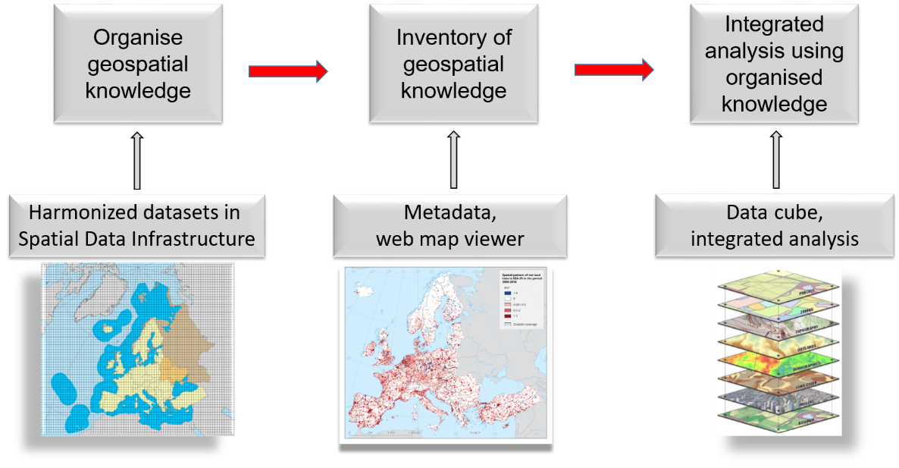

Figure ‑: Organisation of the EEA integrated data platform (IDP). Source: ETC/ULS report 02/2020 Land and ecosystem accounts for Europe, [Towards geospatial environmental accounting](https://www.eionet.europa.eu/etcs/etc-uls/products/etc-uls-report-02-2020-land-and-ecosystem-accounts-for-europe-towards-geospatial-environmental-accounting-1).

The three pillars of the EEA IDP are described below, focusing on the aspects that enable efficient, transparent, quality controlled and repeatable assessments:

1. The inventory of the geospatial accounting knowledge enables datasets to be found according to the analytical question investigated by the user. Each dataset is described by metadata which follow an internationally accepted standard format (INSPIRE metadata). The datasets are stored in a catalogue with their corresponding metadata. In that catalogue, topics or technical terms can be searched, such as agriculture and land use or dataset type and update frequency. An example is the [Environmental Accounting Reference Layers](https://sdi.eea.europa.eu/catalogue/idp/eng/catalog.search)catalogue.
2. Once a dataset is identified as a potential candidate to be used in ecosystem accounts, it can be visualised and explored by means of web map services, using [the IDP map viewer](https://discomap.eea.europa.eu/idp). The map viewer enables the understanding of the spatial extent and the spatial and thematic details of the selected dataset. Datasets can be overlaid, enabling a better design of integrated assessments. For example, the parts of the EU riparian zone network being also part of Natura 2000 areas can be explored, and the spatial coverage can be assessed.
3. The identified geospatial knowledge can then be used for integrated analytics, accounting and as input to modelling. The administrative boundaries, forest and agriculture land cover originate from the same datasets.

The EEA IDP is designed to store datasets in an analysis-ready format. That means that each spatial dataset is converted into a table stored on a server, where each row in the table retains the spatial reference and the reference to the geospatial dataset source. There will be as many tables as investigated analytical questions, e.g. land cover, protected areas, biogeographical regions or biophysical variables such as temperature, rainfall, etc. All tables converted from spatial datasets will have rows which point to the same geographic location.

Storing spatial datasets in data tables has four main advantages. First, these datasets can be accessed by any tabular data software. Second, it can save many steps of data preparation in a GIS software (e.g. administrative regions, land cover and ecosystem extent datasets). Third, several tables, e.g. land cover, biogeographic regions and Natura 2000 boundaries, can be joined into one common database, a so-called data cube. From a data cube spatial calculations can be performed in an efficient, transparent, quality controlled and repeatable way. For example, the area of forest within Natura 2000 areas per EU country. Fourth, as the tables keep the spatial reference, grid or aggregated maps can easily be created from the calculations performed with the data.

The IDP also enables the efficient, transparent, quality controlled and repeatable (easy to update) creation of interactive user interfaces, i.e. dashboards. These support the user in exploring and deriving area statistics of various land cover and land use status and change phenomenon; see this for the interactive dashboard: [Ecosystem Extent Accounts — European Environment Agency (europa.eu)](https://www.eea.europa.eu/data-and-maps/data/data-viewers/ecosystem-extent-accounts?portal_status_message=Changes%20saved.)

This dashboard gives the possibility to explore the European Ecosystem Extent Accounts in various dimensions. The Ecosystem Extent Accounts are organised in three tiers, which are available throughout the different tabs. The individual tabs present different geographic dimensions to be explored (e.g. NUTS 1, 2, 3 areas, Natura 2000 protected area network etc.). The dashboard allows users to build queries flexibly by combining the choices under the drop-down menus for extent account data sets, ecosystem tiers, units (km2 or %) and various geographic entities (EEA-38, EU-27, countries and environmental zones).

## Accounting Items

In addition to recording the opening, closing extents and associated gross and net additions and reductions, two further measurement items are included in the Ecosystem Extent Accounts to improve the analytical insights that they can provide. These comprise:

* *Turnover of ecosystem extent:* This is the gross change in ecosystem extent, the sum of the additions and reductions for an ecosystem type over the accounting period. It includes changes between ecosystem types and also changes between CLC Level 3 classes within the same ecosystem type. This is expressed in absolute terms and also as % of the opening extent.
* *Stable ecosystem stock:* This is the stock of the original ecosystem type that remains unchanged over the accounting period, the opening extent of a given ecosystem type minus the reductions over the accounting period (EEA, 2006a). This is also expressed in absolute terms and as % of opening extent.

## Uncertainty

A final issue to be addressed is uncertainty. Any method of measurement brings with it some uncertainty. For a system based on land cover there is the possibility for error in the interpretation of images with regard to their classification into different CLC classes. This reflects the thematic accuracy of the CLC product. The ambition for the CLC 2000 product was to achieve at least an 85% thematic accuracy. Analysis by the EEA (2006b) suggests that the total reliability of the CLC 2000 product is 87%, although significant variation in accuracy was noted between classes. For example, high class level reliability is observed for Rivers and lakes and low for Sparsely vegetated land. Subsequent editions of the CLC product are also likely to have achieved this threshold for accuracy (see Copernicus Land Services for evolution of CORINE Land Cover[5]).

CLC also works with the majority rule, where minimum mapping units (MMU) are allocated to a CLC class based on the class with the largest extent in that unit. For CLC Land Cover Products the MMU is 25 ha area or 100m width. However, for the CLC change layer the resolution is higher at 5 ha. This may lead to over- or underestimations of the extent of ecosystems for the types with a smaller total area.

The above data uncertainties must be considered when analysing the results of the Ecosystem Extent Accounts. There is now a long-term experience in using the CLC products in European scale analysis (i.e., for the combined extent of the EEA-38 + UK Member States), which can support ‘some rules of thumb’ for establishing thresholds for changes in extent that may be meaningful. The analysis presented herein draws on this and adopts a graduated scale for threshold for reliability when analysing relative changes in ecosystem extent using the 1km2 grid of the LEAC. This is set out in Table 2.2 below, where confidence thresholds for relative change in extent are linked to absolute changes in extent because it is assumed uncertainty will reduce with the area of ecosystem analysed. Indicators of change with moderate confidence criteria in Table 2.2 need to be interpreted with caution and should, ideally, be supported with reference to wider data and studies.

Table .: Uncertainty thresholds for changes in ecosystem extent for European analysis.

|  |  |  |  |
| --- | --- | --- | --- |
| **Relative change in ecosystem extent (%)** | **Absolute change in ecosystem extent (km2)** | | |
| <500km2 | 500 to 2,000km2 | >2,000km2 |
| ≥0.5% change | High extent trend confidence | High extent trend confidence | High extent trend confidence |
| 0.3% to <0.5 change | Moderate extent trend confidence | High extent trend confidence | High extent trend confidence |
| 0.2% to <0.3% change | Extent assumed stable | Moderate extent trend confidence | High extent trend confidence |
| 0.1% to <0.2% change | Extent assumed stable | Extent assumed stable | Moderate extent trend confidence |

## Ecosystem Accounting Areas (Geographical Aggregations)

Whilst the SEEA EEA allows for ecosystem accounts to be compiled for individual assets (e.g. a specific forest) or by specific ecosystem type (e.g., all forest in a country), the ambition of the framework is to provide general guidance on changes in ecosystem related stocks and flows in large and diverse spatial areas. Accordingly, Ecosystem Extent Accounts will generally be produced for relatively large administrative areas. These geographical aggregations are referred to as Ecosystem Accounting Areas, containing a number of different ecosystem types.

Tier I to III Ecosystem Extent Accounts can be produced for the full extent of Europe. However, more analytical value may be added when compiling accounts for ecosystem accounting areas or types of particular geographical, land management and environmental policy interest. For example, by creating accounts for different biogeographical regions or using the accounts to understand ecosystem transitions associated with urbanisation.

The set-up of the EEA IDP underpinning the calculation of Ecosystem Extent Accounts allows them to be readily calculated for various ecosystem accounting areas. These Ecosystem Accounting areas can be of flexible size and shape, relating to administrative areas (e.g. municipalities or provinces) or bio-geographical units, such as water basins or mountain ranges. They will often be contiguous areas but can also be split up in (sometimes many) different blocks (UN et al., 2014). This opens up opportunities for analysing the stability of ecosystems and magnitude of changes in their extent in relation to various policy questions and targets. Different policy targets often set objectives that relate to specific geographic areas (e.g., the EU Natura 2000 network), land use types (e.g. forestry) or individual ecosystem components (such as a river basin or semi-natural Grasslands).

Where policy targets have a certain geographic and thematic focus then ecosystem accounting areas can be set up flexibly (see section 4). This report provides Ecosystem Extent Accounts for various Ecosystem Accounting Areas to inform on different policy, management and ecological concerns:

* EEA-38 + UK and EU-27 + UK countries;
* Biogeographical regions;
* Urban ecosystems; and the
* Natura 2000 network.

# Tier I European Ecosystem Extent Accounts

This section presents the Tier I Ecosystem Extent Accounts calculated using the MAES typology and the updated LEAC database. The Tier I Ecosystem Extent Accounts record changes in the extent of broad ecosystem types, following the general format proposed in the SEEA EEA. The accounts have been compiled at the European scale (for the EEA-38+UK and EU-27+UK) and biogeographical region given the European policy interest. In addition, Annex 3 of this document, which is available as separate file, provides Tier I Ecosystem Extent Accounts compiled for every single EEA-38 member country and the UK. These are intended to support the analyses of ecosystem extent trends for individual countries or groups of countries and provide a foundation for wider ecosystem accounting or assessment analyses, such as ecosystem service modelling.

The accounting results in this document are presented in tables, graphs and maps. The glossary at the front of this report provides a description of all the terms used in these Tier I Ecosystem Extent Accounts. A summary of the key results from the Tier I European Ecosystem Extent Accounts is provided in Box 3‑1.

Box ‑: Key results from the analysis of Tier I European Ecosystem Extent Accounts for the 2000 to 2018 period.

* Significant increases in Urban ecosystem extent (6.6% in the EEA-39 and 5.8% in the EU-27 + UK). Some biogeographical regions with large coastal areas (including the Mediterranean and Black Sea) were found to exhibit particularly high rates of increase in Urban ecosystem extent.
* Limited increases in Rivers and lakes ecosystem extent (1.5% in the EEA-38 + UK and 1.2% in the EU-27 + UK), mainly driven by increases in the Mediterranean biogeographical region (probably due to an increase of reservoirs and other artificial water bodies).
* Some decreases in the extent of (semi-)natural ecosystem types:
  + Particularly Grassland and Heathland and shrub in both the EEA-39 and EU-27 + UK (around 1.0%). The reduction in Grassland extent includes relatively high losses in the Boreal region. The reduction of Grassland at the EEA-39 scale is driven by reductions in the Boreal, Atlantic, Anatolian and Mediterranean regions. The reduction in the extent of Heathland and shrub is mainly driven by losses in the Mediterranean biogeographical region.
  + Declines for Inland wetlands in the EU-27 + UK (-0.5%), driven by losses in the Atlantic biogeographical region.
* Relatively high levels of turnover in the extent of Forest and woodland and Urban ecosystems, particularly Forest and woodland in the Boreal biogeographical region. The latter is likely due to timber harvesting rotations which lead to a temporary re-classification as non-forest area.
* Ongoing loss of cropland in the EU-27 + UK and EEA-39 areas (whilst small in relative terms, still large in absolute terms).

## Tier I Ecosystem Extent Accounts (EEA-38 + UK)

Table 3.1, Table 3.2 and Table 3.3 show the changes in ecosystem extent for the periods 2000 to 2006, 2006 to 2012 and 2012 to 2018, across the EEA-38 + UK countries collectively. The accounts show changes in ecosystem extent in absolute terms (km2) and as a percentage of the initial ecosystem stock, as well as reductions, additions, turnover and the extent of stable (opening extent minus reductions). This information is presented in the rows of Table 3.1, Table 3.2 and Table 3.3. The data for each ecosystem type are organised in the columns and are aggregated to a total in the final column of the tables. The total extent stays the same for both opening and closing periods for 2000, 2006, 2012 and 2018 (5,855,212 km2). Although expected, this demonstrates that the accounts are internally consistent, with the extent of different ecosystem types consistently aggregating to the same EEA-38 + UK accounting area.

A key observation from Table 3.1, Table 3.2 and Table 3.3 is that ecosystem extent tends to be quite stable in the EEA-38 + UK (around 99 % or more of the ecosystem extent is stable between 2000 and 2006, 2006 and 2012 and 2012 and 2018). These high rates of stability show that ecosystems in Europe are generally not highly dynamic (at least as broad Tier I type), although there are likely to be regions that exhibit a lower stability in ecosystem type. This is all reflected in the low turnover rates of around 1% for both accounting periods, with the exception of Forest and woodland and Urban ecosystems.

The least stable ecosystem is forest (around 97% stable ecosystem extent), and relatively high levels of total turnover (gross changes) of 4.9 % to 7.0 % over the three accounting periods. Urban ecosystems also exhibit relatively high turnover rates of 3.6 to 4.5% over the different accounting periods.[6] This high rate of turnover for Forest and woodland may be due to internal conversions within the boundaries of the ecosystem (i.e. forest felling and regeneration), which are included into the calculations of the turnover rate. This issue is further analysed in Section 0. Besides residential areas, Urban ecosystems include areas of economic activities, such as mineral extraction sites and construction sites, which may explain the high turnover rates.

A summary of the results reported in Table 3.1, Table 3.2 and Table 3.3 is provided in Figure 3‑1, which shows the extent of MAES ecosystem types in 2000 and 2018 (blue and orange bars, respectively) and the change in stock over this period as a percentage (red and green figures to the right of the bars). As shown in Figure 3‑1, the ecosystem types of Cropland as well as Forest and woodland dominate in the EEA-38 + UK accounting area. They each account for in excess of 2 million hectares out of the total EEA-38 + UK extent of just under 6 million hectares. Of the remaining ecosystems, only Grassland extent exceeds 500,000 km2. The extent of Marine inlets and transitional waters is below 30,000 km2, while the remaining ecosystems vary in extent between approximately 100,000 km2 and 350,00km2.

Table .: Tier I Ecosystem Extent Account, EEA-38 + UK countries, 2000 – 2006.

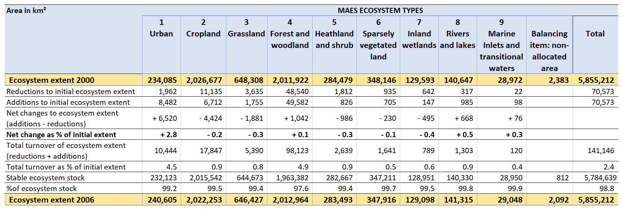

Table .: Tier I Ecosystem Extent Account, EEA-38 + UK countries, 2006 – 2012.

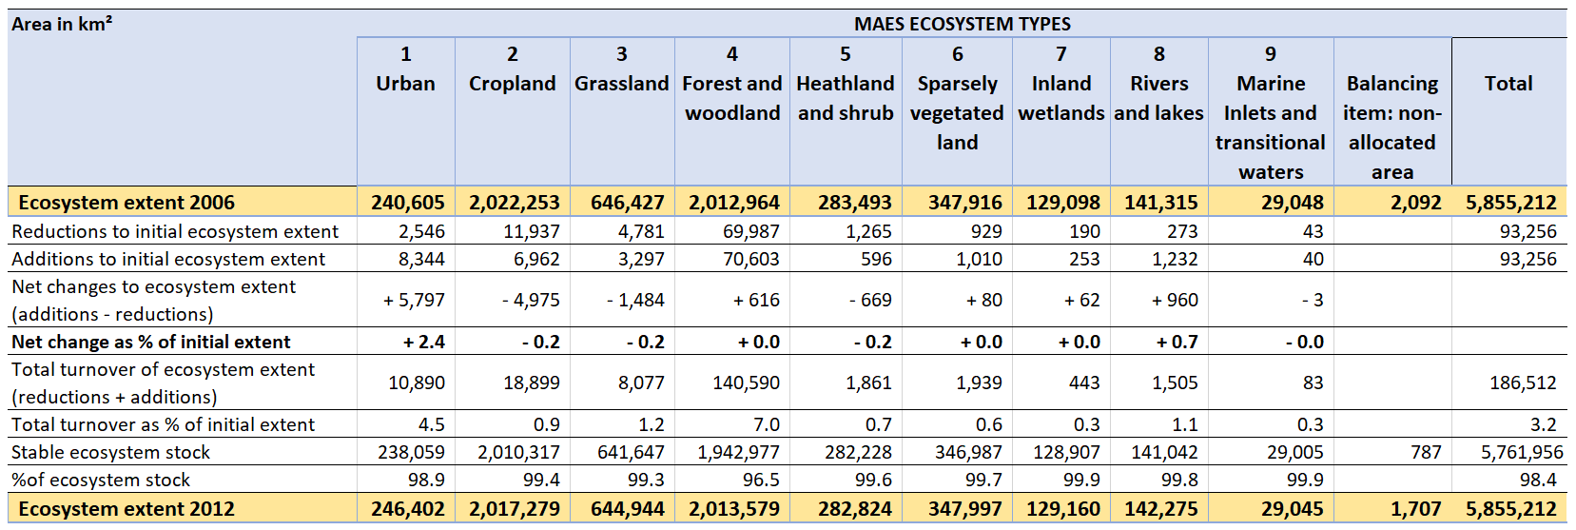

Table .: Tier I Ecosystem Extent Account, EEA-38 + UK countries, 2012 – 2018.

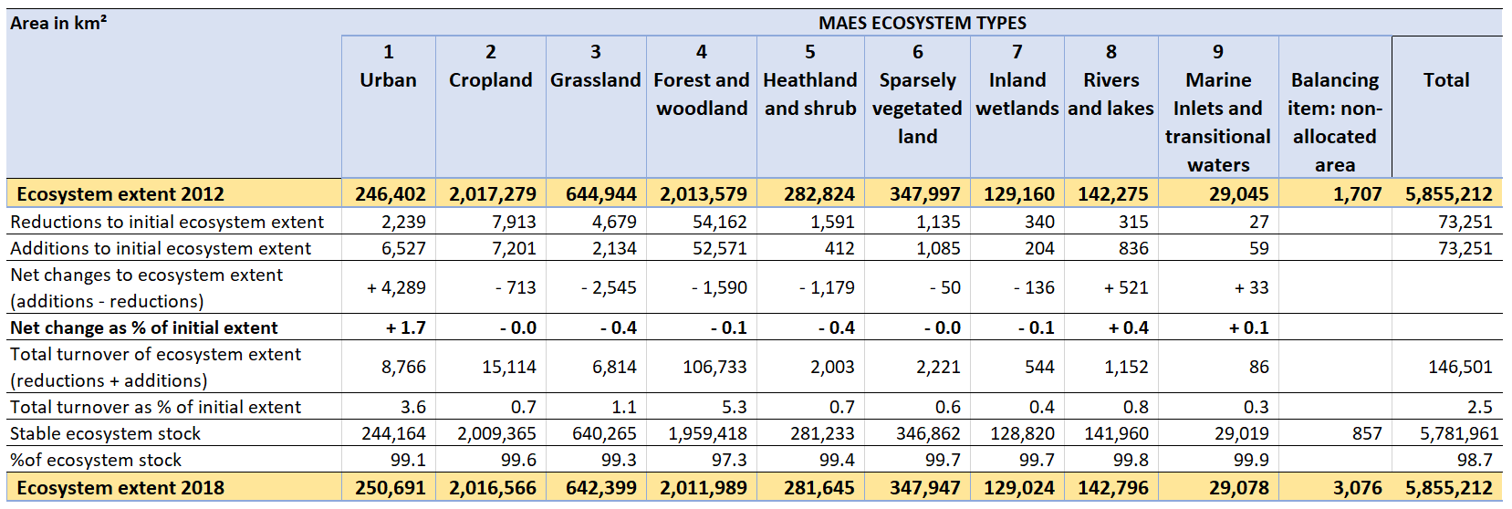

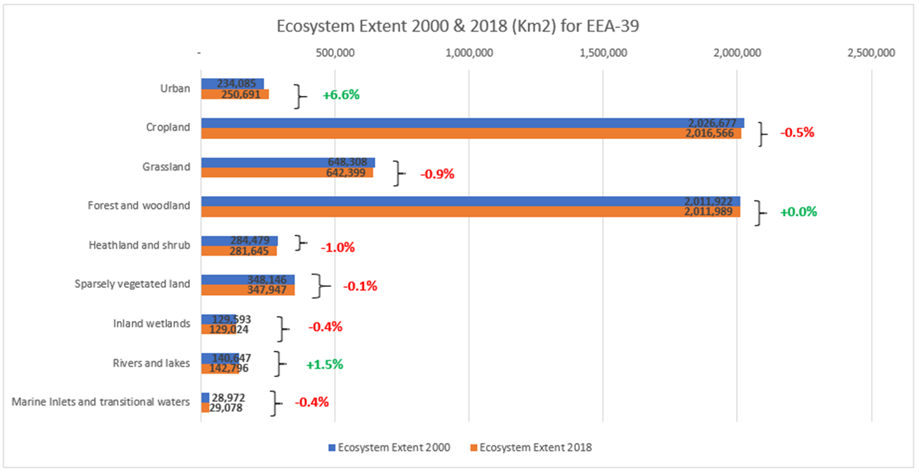

Figure ‑: Tier I ecosystem extent and relative change, EEA-38 + UK countries, 2000 – 2018.

Figure 3‑1 reveals that Urban ecosystems show the highest relative increase in extent between 2000 and 2018 (6.6 % or +16,606 km2 based on the 2000 opening extent of 234,085 km2). As shown in Tables 3.1, 3.2 and 3.3, these increases represent the largest increases in absolute extent of any ecosystem type in the EEA-38 + UK. With respect to the thresholds established in Table 2.2, this implies a high level of confidence in the trend of increasing urbanisation in the EEA-38 + UK. This observed urban sprawl is believed to be due to economic sprawl and urban management, as residential sprawl has been declining since 1990 (EEA, 2016b).

Figure 3‑1 also shows that the extent of the ecosystem type Rivers and lakes increased between 2000 and 2018 (by 1.5 % or 2,149 km2 based on an opening extent of 140,647 km**2**), the second largest increase after Urban ecosystems. Again, based on the thresholds established in Table 2.2, this implies a high level of confidence in the trend of increasing extent of River and lakes ecosystems in the EEA-38 + UK. This observed increase may at least partly be attributed to the creation of artificial lakes and reservoirs as a result of mineral extraction activities and water management, often for irrigation purposes (EEA, 2010).

The extent of Marine inlets and transitional waters also slightly increases in Figure 3‑1 over the accounting period 2000-2018 (0.4% increase, albeit only +106 km2 in absolute terms). The figure also reveals reductions in the extent of Heathland and shrub (-1.0 % or -2,834 km2) and Grassland (-0.9 % or -5,909 km2). Based on the thresholds established in Table 2.2, a high degree of confidence is attributed to these negative trends. The decline in Heathland and shrub may represent the greatest environmental concern, given the relatively small opening extent of this ecosystem type in the EEA-38 + UK (284,479 km2) compared to Grassland (648,308 km2).

Inspection of Table 3.1, Table 3.2 and Table 3.3 also reveals that, with the exception of Cropland, Heathland and shrub and Grassland are the only ecosystems to exhibit consistent reductions in extent between 2000 and 2006 (-986 km2 for Heathland and shrub and -1,881 km2 for Grassland), 2006 and 2012 (***-***669 km2 and -1,484 km2, respectively) and 2012 and 2018 (- 1,179 km2 and -2,545 km2, respectively). The reduction in the extent is highest between 2012 and 2018.

For Cropland, Figure 3‑1 reveals a decline in ecosystem extent of 0.5 % between 2000 and 2018 (equivalent to -10,111 km2). Whilst there is high confidence in this trend implying a meaningful change, the opening extent (2,026,677 km2) and closing extent (2,016,566 km2) remain substantial. Negative trends in extent are also observed for Inland wetlands (by -0.4% or -569 km2). A high level of confidence is attributed to this trend. Table 3.1 reveals that these reductions in extent are largely caused by reductions between 2000 and 2006 (-495 km2).

Figure 3‑1 illustrates that the Forest and woodland ecosystems extent is stable between 2000 and 2018 (+0.0 %). However, Table 3.1 reveals that these ecosystems show the second largest net increases in extent in absolute terms between 2000 and 2006 (+1***,***042 km2). This net increase and subsequent raise between 2006 to 2012 (+616 km2, see Table 3.2) are offset by reductions between 2012 and 2018 (-1,590 km2, see Table 3.3). In combination with the high turnover rates previously identified, this suggests Forest and woodland ecosystems extent may be quite dynamic. The extent of Sparsely vegetated land is also shown to stay the same between 2000 and 2018 (change of -0.1% and -199 km2 in absolute terms, Figure 3‑1).

## Tier I Ecosystem Extent Accounts (EU-27 + UK)

Table 3.4, Table 3.5 and Table 3.6 show the Tier I Ecosystem Extent Accounts for the EU-27 + UK area as a whole for the periods 2000 to 2006, 2006 to 2012 and 2012 to 2018, respectively. The opening and closing extents of all ecosystems in the EU-27 + UK are 4,399,232 km2 in all three tables, again demonstrating that the accounts are internally consistent.

Table 3.4 shows that the highest turnovers in ecosystem extent between 2000 to 2006 are observed for Forest and woodland (5.5%) and for Urban (4.3 %) ecosystems. Similar turnover rates are also observed in Table 3.5 and Table 3.6 for the two subsequent accounting periods 2006 to 2012 and 2012 to 2018 (Forest and woodland: 8.2 and 6.0%, Urban: 4.1 and 2.8%, respectively). The turnover in Forest and woodland is believed to reflect rotational forest management practices rather than a long-term change between CLC classes of the forest ecosystem type, as discussed with respect to the EEA-38 + UK analysis. All other ecosystems show a significantly lower turnover rate of around 1% (maximum 1.4% for Grassland between 2006 and 2012).

These different turnover rates imply that Forest and woodland ecosystem type exhibits the lowest % of stable ecosystem stock between 2000 and 2006 (97.3%), 2006 and 2012 (95.9%) and 2012 and 2018 (97%). The percentage of stable ecosystem stock is 99% or greater in all three accounting periods for the other ecosystem types. This again indicates that ecosystems in the EU-27 + UK are not highly dynamic with respect to changes in extent.

A summary of the results reported in Table 3.4, Table 3.5 and Table 3.6 is provided in Figure 3‑2, which reveals a similar distribution of ecosystems in the EU-27 + UK area as the EEA-38 + UK. The Cropland as well as Forest and woodland ecosystems dominate the accounting area, each comprising approximately 1.6 million hectares out of the total extent of approximately 4.4 million hectares. Of the remaining ecosystems, only Grassland extent exceeds 500,000 km2. Urban ecosystems then exhibit the fourth highest extent, around 220,000 km2 in 2018, while the remaining terrestrial ecosystems vary in extent between approximately 60,000 km2 and 180,00 km2.The extent of Marine and transitional waters accounted for approximately 25,000 km2.

Similarly to the EEA-38 + UK areas, Figure 3‑2 shows that Urban ecosystems present the largest relative increases in extent, with +5.8% between 2000 and 2018. Again, Table 3.4, Table 3.5 and Table 3.6 reveal that Urban ecosystems also exhibit the largest net increase in absolute extent between 2000 and 2006 (+5,532 km2), 2006 and 2012 (+4,610 km2) and 2012 and 2018 (+2,651 km2). With respect to the thresholds established in Table 2.2, this implies a high level of confidence in the trend of increasing urbanisation in the EU-27 + UK. However, the rate of urbanisation (in spatial terms) is shown to have reduced over the three accounting periods.

Rivers and lakes also increase in extent between 2000 and 2018 (+1.2%, Figure 3‑2) in the EU-27 + UK, with a high level of confidence attributed to this trend. The potential reasons for the increase in the extent of these ecosystems are highlighted and discussed with respect to the EEA-38 + UK analysis above. Increases in ecosystem extent are also observed for Sparsely vegetated land (+0.5%, or 333 km2) in the EU-27 + UK. This trend is the only one that is different in direction than that observed for the EEA-38 + UK (-0.1% between 2000 and 2018). Based on the thresholds in Table 2.2, a high level of confidence is attributed to this trend in the EU-27 + UK. The extent of Forest and woodland ecosystems in the EU-27 + UK is considered to be stable over the 2000 to 2018 accounting period.

Declines in extent of Heathland and shrub (-1.2%) and Grassland (-0.8%) are also shown in Figure 3‑2. Based on Table 2.2, a high level of confidence is attributed to both of these trends. Figure 3‑2 also identifies that the rate of loss of Heathland and shrub may be a concern given the relatively small closing extent of this ecosystem in the EU-27 + UK (approximately 182,000 km2 in 2018). For Grassland, the reduction in extent is associated with a relatively larger stock of approximately 500,000 km2 in 2018. The relative reductions in extent of both of these ecosystems in the EU-27 + UK is very similar to that noted for the EEA-38 + UK area.

Table 3.4: Tier I Ecosystem Extent Account, EU-27 + UK countries, 2000 – 2006.

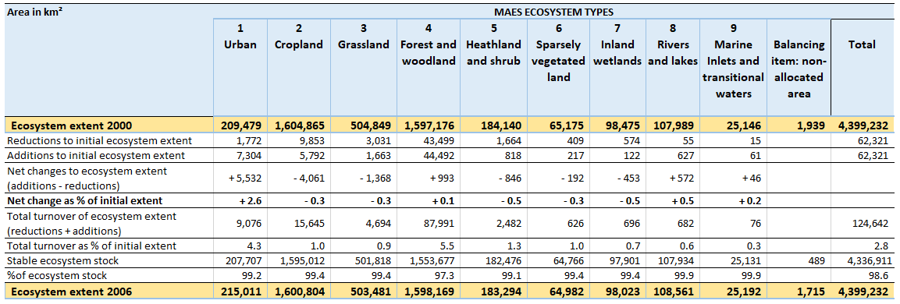

Table .: Tier I Ecosystem Extent Account, EU-27 + UK countries, 2006 – 2012.

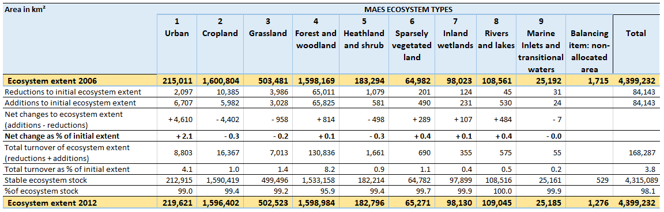

Table .: Tier I Ecosystem Extent Account, EU-27 + UK countries, 2012 – 2018.

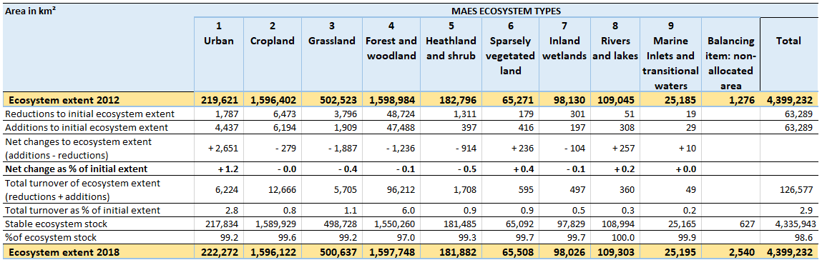

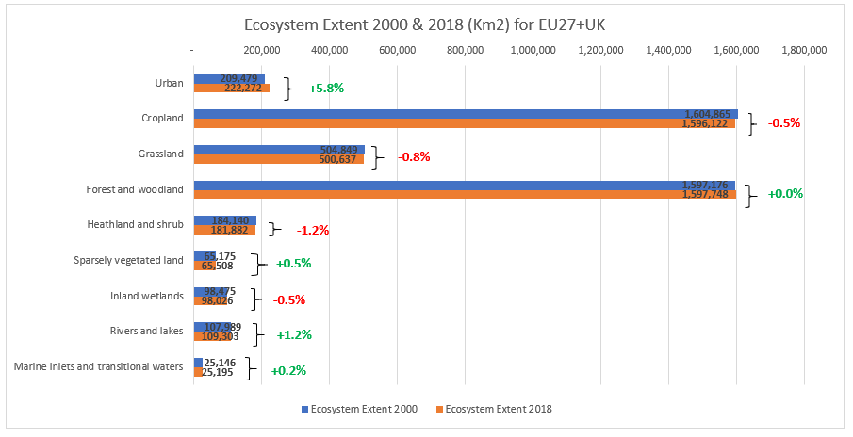

Figure ‑: Tier I ecosystem extent and relative change, EU-27 + UK countries, 2000 – 2018.

With a moderate level of confidence, the results presented in Figure 3‑2 also show that there has been an overall decline in Inland wetlands extent between 2000 and 2018 (-0.5%). The net changes in the extent of this ecosystem in Table 3.4 (-453 km2), Table 3.5 (+107 km2) and Table 3.6 (-104 km2) imply that any downward trend may have been stabilised since 2006. However, further evidence should be obtained to support this conclusion.

As for the EEA-38 + UK analysis, Figure 3‑2 reveals a decline in Cropland ecosystem extent of 0.5% between 2000 and 2018 (equivalent to 8,743 km2) in the EU-27 + UK. This is associated with substantial closing extent of approximately 1.6 million Km2. The extent of Marine inlets and transitional waters remains, essentially, constant over the 2000 to 2018 accounting period (an increase of 0.2% is observed but this is only 49 km2 in absolute terms).

## Tier I Ecosystem Extent Accounts by biogeographical region (EEA-38 + UK)

The Ecosystem Extent Accounts compiled at the European scale (e.g., EEA-38 + UK or EU-27 + UK) depict a broad picture of the status and changes of ecosystems in Europe. However, the set-up of the EEA geo-spatial database underpinning its accounting system allows information on the changing composition of ecosystem types to be readily organised for different ecosystem accounting areas. Because of this basic set-up, Ecosystem Extent Accounts can be compiled to inform a variety of analytical assessments to support policy analysis and inform on management objectives.

In this regard, the biogeographical regions of Europe divide the European landscape into coherent areas, which exhibit common characteristics of habitats and species (Roekaerts, 2002). Therefore, they represent key ecosystem accounting areas of environmental management concern. These biogeographical regions have been elaborated around the year 2000 (EEA, 2002). Eleven biogeographical regions have been defined: Alpine, Anatolian, Artic, Atlantic, Black Sea, Boreal, Continental, Macaronesia, Mediterranean, Pannonian and Steppic, as shown on Map 3‑1.

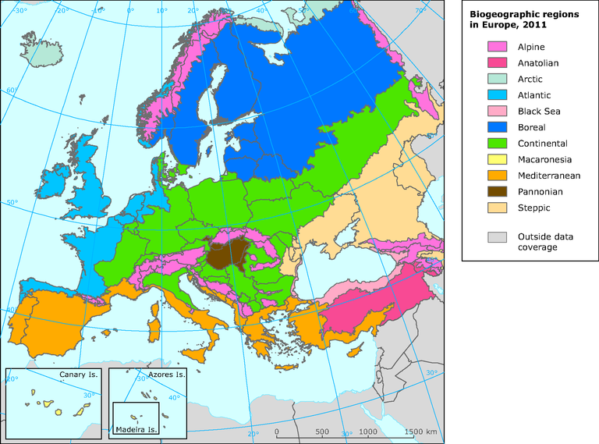

Map ‑: Biogeographic regions in Europe.

Calculating Tier I Ecosystem Extent Accounts by biogeographical region can directly support specific policy applications, such as the objectives of the Habitats Directive (EC, 1992) or the Convention on the Conservation of European Wildlife and Natural Habitats (the Bern Convention; Council of Europe, 1979).

Table 3.7 presents the Tier I Ecosystem Extent Accounts for the EEA-38 + UK area for the period 2000 to 2018 by biogeographical region. It should be noted that it was not possible to achieve an exact harmonisation between the boundaries of the biogeographical regions and the spatial extent of the EEA-38 + UK area in the LEAC database (the difference is around 1%).[7] This is due to the fact that the borders of the biogeographic regions presented above were spatially aligned with the European landmass when originally established, and hence do not include a substantial part of coastal habitats nor the marine ecosystems combined under the Tier I ecosystem type Marine inlets and transitional waters. To rectify this discrepancy a spatial re-definition of the biogeographic regions with sea boundaries, it would be necessary to include additional sea area in order to match the total extent of the CLC data sets underpinning the ecosystem map. For various reasons this is currently not feasible.

Figure 3‑3 summarises the closing extents of ecosystem extent per biogeographic region in 2018 as a percentage of the total area reported in Table 3.7. This illustrates the main characteristics of the different biogeographic regions.

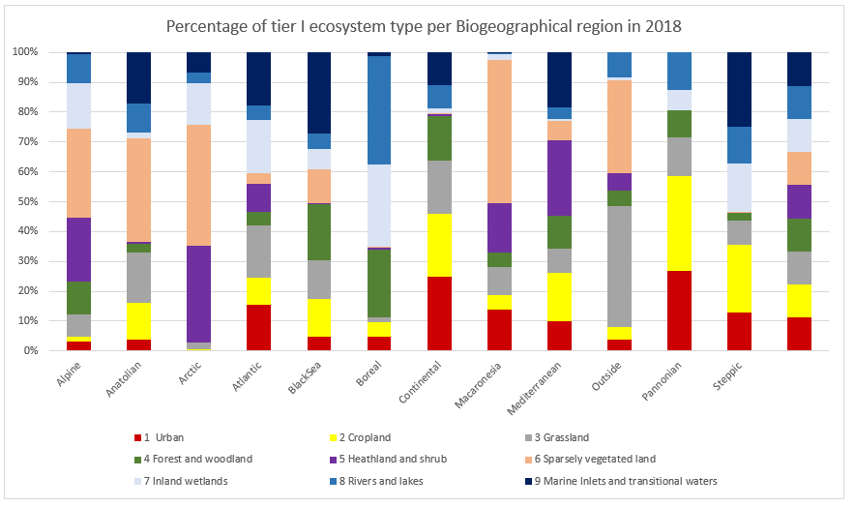

Figure ‑: Percentage of MAES ecosystem type per biogeographic region, 2018.

In Figure 3‑3, the Steppic and Pannonian regions are dominated by Cropland, while the Boreal regions show a high share of Forest and woodland ecosystems, and the Alpine and Arctic regions a large proportion of both Heathland and shrub and Sparsely vegetated land. The Arctic biogeographic region also shows the highest rate of urban development (+21.5%, Table 3.7), although this is associated with a low opening extent (304 km2 in 2000). Substantial levels of urbanisation are also observed in the Anatolian (+20.3%, associated with relatively small opening extent of 5,683 km2), Mediterranean (+15.7%, associated with a relatively large opening extent of 35,013 km2), Black Sea (+15.2%, associated with relatively small opening extent of 1,562 km2) and Macaronesia (+10.9%, associated with a small opening extent of 594 km2). The high rates of increase in Urban ecosystem extent in the Mediterranean, Black Sea and Macaronesia biogeographical regions indicate that urbanisation may be a particularly important phenomenon in some coastal areas. In other biogeographical regions Urban ecosystems increased, yet by less than 10% between 2000 and 2018.

The results for Rivers and lakes show high increases in extent for a number of the biogeographic regions, especially for the Black sea (+13.9%) and the Mediterranean (+12.0%). In absolute terms, the increases are most substantial in the Mediterranean (+994 km2), compared to the Black Sea (+132 km2). These substantial increases are probably due to the creation of large reservoirs for irrigation and energy generation purposes in summer-dry regions. The change in extent associated with the Mediterranean region (+994 km2), represents nearly half of the total increase in extent reported for the EEA-38 + UK as a whole (see Figure 3‑1). Elsewhere, increases in the extent of River and lakes of between 1 and 4% are observed in the Anatolian (3.7%), Pannonian (2.5%), Continental (2.4%) and Atlantic (1.5%) and Macaronesia (1.4%) biogeographical regions between 2000 and 2018. The only biogeographical area in which the extent of Rivers and lakes decreased was the Arctic (-0.9%), albeit by only -17km2 in absolute terms.

The highest relative losses of Heathland and shrub reported in Table 3.7 are in the Mediterranean region, where a decrease of 2.0% represents the highest absolute decrease of -2,302 km2 of this ecosystem in any biogeographical region. This is associated with an opening extent of 117,275 km2 in 2000. The loss of Heathland and shrub ecosystems in the Mediterranean biogeographical region is driving the losses in this ecosystem observed at the European scale (Figure 3‑1 shows overall loss of -2,834 km2 between 2000 and 2018 in the EEA-38 + UK).

High relative losses of Grassland are recorded for the Boreal region (-7.9%, equivalent to a loss of -1,376 km2). Similar losses in absolute terms are observed in the following biogeographic regions: Atlantic (-1,561 km2, or -0.8%); Anatolian (-1,048 km2, or -1.3%); and, Mediterranean (-1,030 km2, or -1.2%). The only biogeographical region in which Grassland extent increased between 2000 and 2018 was the Arctic (by 2.0%, or +112 km2).

Inland wetlands show net reductions in extent for most of the biogeographic regions. Atlantic region exhibited the highest loss in absolute terms (-389 km2 from an opening extent of 39,595 km2 in 2000, or -1.0%). This is driving the changes in Inland wetlands extent observed at the European scale. The largest relative decreases in the extent of this ecosystem were observed in the Anatolian region (-2.4%, or -43 km2). Decreases in extent of around 25 to 35 km2 were also observed in the Boreal, Black Sea and Mediterranean biogeographical regions. The only biogeographical region in which Inland wetlands extent increased between 2000 and 2018 was the Continental (by +0.3%, or +11 km2).

Table .: Tier I Ecosystem Extent Accounts by biogeographical region, EEA-38 + UK countries, 2000 – 2018.

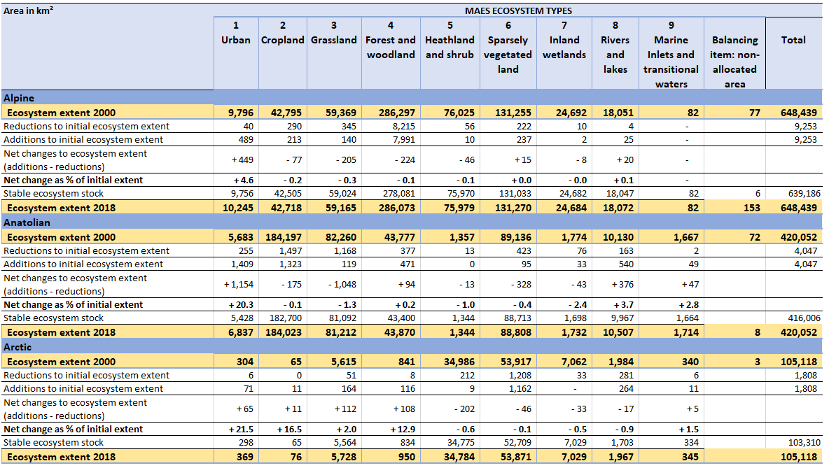

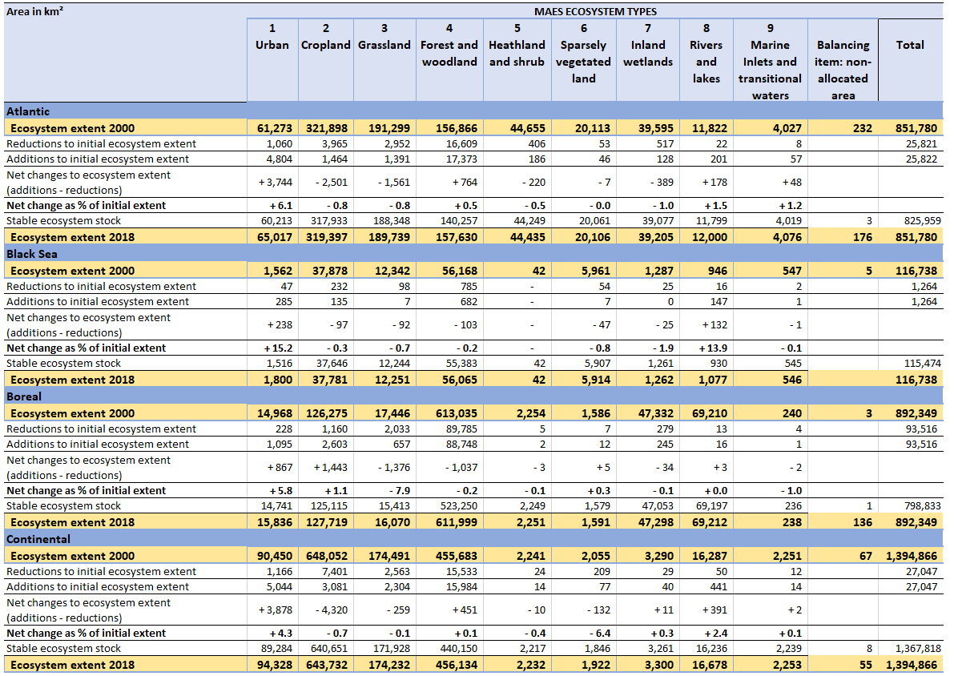

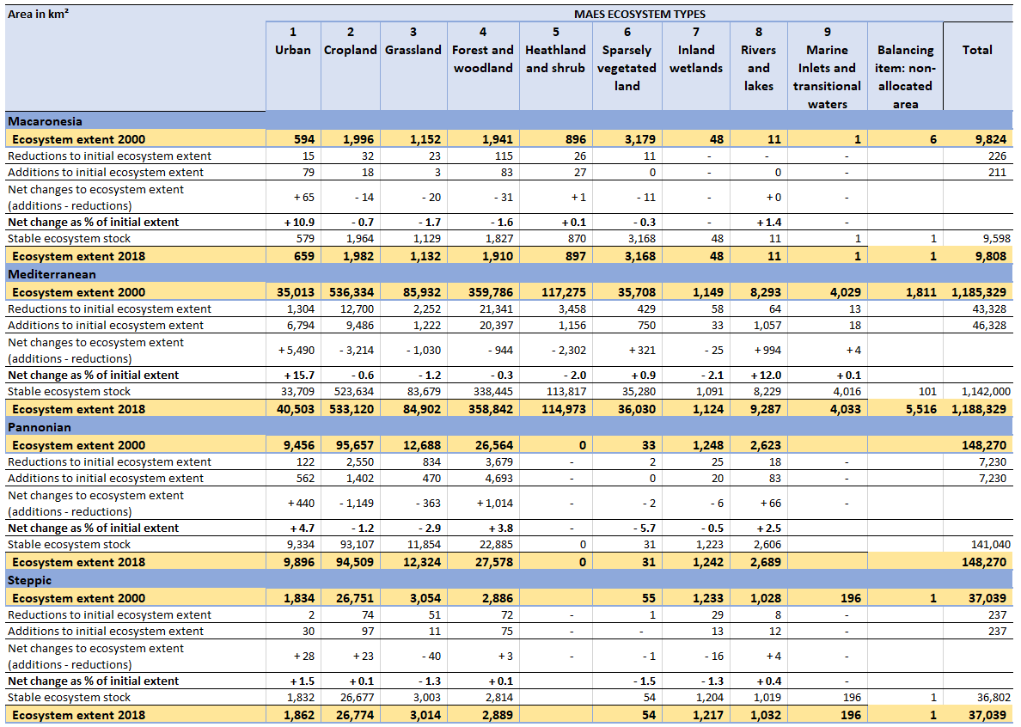

Cropland exhibits the highest relative decrease in extent in the Pannonian biogeographical region (+1.2%, or -1,149 km2). However, the highest losses in absolute terms are observed in the Continental (-4,320 km2, or -0.7%), Mediterranean (-3,214 km2, or -0.6%) and Atlantic (-2,501 km2, or -0.8%) biogeographical regions. Cropland shows an increase in the Boreal (+1,443 km2, or +1.1%), Steppic (+23 km2, or +0.1%) and Arctic (11km2, or +16.5%) biogeographical regions only. Whilst the extent of Cropland in the Arctic remains small (76 km2), research suggests increasing global temperatures may lead in the future to a larger farmed area in this biogeographical region (Uleberg et al., 2014).

Forest and woodland ecosystems exhibit the highest turnover in the Boreal biogeographical region, where only 523,250 km2 out of the 613,035 km2 opening extent in 2000 remains unchanged until 2018. Significant extents of Forest and woodland ecosystem are also subject to turnover in the Mediterranean (338,445 km2 out of 359,786 km2 stable between 2000 and 2018) and Atlantic (140,257 km2 out of 156,866 km2 stable between 2000 and 2018) biogeographical regions. This is likely due to harvesting rotations.

Whilst Figure 3‑1 shows that Sparsely vegetated land is relatively stable in extent between 2000 and 2018 at the EEA-38 + UK scale (net change of -0.1%), decreases in extent are observed in the Anatolian (-328 km2, or -0.4%), Continental (-132 km2, or -6.4%) and Black Sea (-47 km2, or -0.8%) biogeographical regions. However, in absolute terms, these are offset by increases in the Mediterranean (+0.9%, or +321 km2) region. Figure 3‑1 shows the extent of Marine inlets and transitional waters to be stable at the EEA-38 + UK scale. However, Table 3.7 reveals small increases in extent in the Anatolian (+2.8%, or +47 km2) and Atlantic (+1.2%, or +48 km2) biogeographical regions.

# Analysing Tier I Ecosystem Extent Accounts for ecosystem types and accounting areas of policy interest

Biogeographical regions represent an example of geographical areas of policy interest. However, the flexible nature of the geo-spatial database used to organise information on ecosystem extent opens opportunities for focusing the analysis on specific ecosystem types and other geographical areas of policy interest*.* As shown in the Tier I Ecosystem Extent Accounts for the EEA-38 + UK and EU-27 + UK (Chapter 3), the largest relative and absolute changes in extent between 2000 and 2018 in Europe are associated with Urban ecosystems. As such, urbanisation and trends in the extent of Urban ecosystems is now a policy concern for Europe (EEA-FEON, 2016).

The Natura 2000 network has been established to ensure the long-term survival of Europe's most valuable and threatened species and habitats as established under the EU Habitats and Birds Directives (EC, n.d.). Understanding trends of different ecosystem types within Natura 2000 areas is therefore of particular policy interest.

This chapter presents Tier I Ecosystem Extent Accounts and a more detailed analysis relevant to these two policy interests. A summary of the key results from these Tier I Ecosystem Extent Accounts for ecosystem types and accounting areas of policy interest is provided in Box 4‑1.

Box ‑: Key results from the analysis of Tier I Ecosystem Extent Accounts for comparing trends inside and outside Natura 2000 sites for the 2000 to 2018 period.

* The increases in Urban ecosystems extent in Europe are generally due to conversion of Cropland, although differences emerge at a country level. In the Nordic countries and Slovenia and Portugal, Forest and woodland are the most impacted ecosystems from urban expansion. In Iceland, the most impacted are Heathland and shrub, and Grassland in Ireland.
* Urbanisation is the main driver of reductions in Grassland ecosystem extent in Europe.
* Comparison of the ecosystem extent in areas of high percentage cover by Natura 2000 sites with areas with no Natura 2000 coverage revealed:
  + The extent of Forest and woodland ecosystems is substantially higher inside the Natura 2000 network compared to outside;
  + Ecosystem turnover is lower for Forest and woodland, Grassland, Heathland and shrub and Sparsely vegetated land ecosystems inside the Natura 2000 network;
  + The proportion of Heathland and shrub, Sparsely vegetated land, Inland wetlands, Rivers and lakes and Marine inlets and transitional waters is approximately a factor of 3 higher for Natura 2000 areas compared to the rest of the EU-27 + UK;
  + The proportion of Cropland and Urban ecosystems is higher outside the Natura 2000 network;
  + The rate of decrease in Cropland, Grassland, Heathland and shrub, and Inland wetlands extent is lower in Natura 2000 areas than outside them; and,
  + Net relative changes in ecosystems extent are lower in all ecosystems except Urban in the Natura 2000 network. Indicating these ecosystems are more stable.

## Urbanisation (EEA-38 + UK)

The Tier I Ecosystem Extent Accounts reveal that the largest relative and absolute changes in extent between 2000 and 2018 in the EEA-38 + UK are associated with Urban ecosystems. Urbanisation deserves specific attention, as urban land use activities and patterns have a particular impact on the environment, e.g. through fragmentation or soil sealing. Table 4.1 explores this further by presenting the ecosystem losses connected to urbanisation in the EEA-38 + UK area between 2000 and 2018 by country. It sheds light on the ecosystems most affected by urbanisation and how this varies across the various EEA-38 + UK countries.

In Table 4.1, columns 2 to 9 provide the area in hectares of ecosystems converted to Urban ecosystems between 2000 and 2018 and column 10 from the non-allocated area. The rows organise this information by country and the EEA-38 + UK (and 28 EU Member States, EU-27 + UK) area as a whole.

The final column aggregates the total area of non-Urban ecosystems that were converted to Urban during the period 2000-2018. It should be noted that these represent gross additions to the Urban ecosystems stock at the MAES typology scale ([8]).

As revealed by Table 4.1, the ecosystem type with the largest extent converted to urban land use in the EEA-38 + UK between 2000 and 2018 is Cropland. In total, 1,091,146 ha of Cropland was converted to Urban ecosystems in the EEA-38 + UK, equivalent to 61 % of the total ecosystem loss to urban sprawl. In Denmark and Italy, over 90% of urban expansion occurred on Cropland ecosystems between 2000 and 2018 and overall, 25 out of the EEA-38 + UK countries show that in excess of 50% of urban expansion was from conversion of Cropland.

Grassland ecosystems are the second most affected by urbanisation in Europe, with approximately 17% of urban expansion occurring on Grassland ecosystems between 2000 and 2018 in Europe. In Ireland 64% of urbanisation was from Grassland conversion between 2000 and 2018, although this figure is <40% in other EEA-38 + UK countries. A comparison of the reduction in Grassland ecosystems extent due to urbanisation with the net changes in the extent of this ecosystem type (Table 3.1 to Table 3.3), reveals that urban sprawl is the main driver of Grassland ecosystems loss in Europe. Indeed, it is likely that urbanisation accounts for around half of the Grassland ecosystems loss observed in Europe ([9]).

For Europe as a whole, approximately 15% of urban expansion was onto Forest and woodland ecosystems. At the country level, Forest and woodland ecosystems are most affected by urbanisation in the Nordic countries of Finland (8% of urban expansion on Forest and woodland ecosystems between 2000 and 2018), Norway (72%) and Sweden (65%). This is also true for Slovenia, Portugal, Estonia, Montenegro and Croatia, where around 50% of urban expansion between 2000 and 2018 was on Forest and woodland ecosystems.

Some countries show a more diverse range of ecosystem types lost to urbanisation. In the UK, for example, approximately 45% of the new urban area was built on Cropland, 36% on Grassland and around 10% on Forest and woodland. Iceland, on the other hand, shows there can be clear country level differences as Heathland and shrub is the main ecosystem type consumed by urban sprawl (70% of all urban expansion was on Heathland and shrub ecosystems between 2000 and 2018).

The extent of Heathland and shrub lost to urbanisation (61,861 ha) and Inland wetlands (10,493 ha) in the EEA-38 + UK was lower than that of Cropland, Grassland and Forest and woodland ecosystems. A similar analysis as that conducted for Grasslands suggests that urbanisation accounts for around 20 % of the net loss of these ecosystem types between 2000 and 2018 in the EEA-38 + UK. However, the proportion may be higher in some regions or accounting areas.

Table .: Gross Urban ecosystem increase by MAES type for EEA-38 + UK countries, 2000 – 2018.

| **Area in ha** | **2  Cropland** | **3  Grassland** | **4  Forest and woodland** | **5  Heathland and shrub** | **6  Sparsely vegetated land** | **7  Inland wetlands** | **8  Rivers and lakes** | | **9  Marine inlets and transitional waters** | **Gross Urban ecosystem additions 2000-2018** |
| --- | --- | --- | --- | --- | --- | --- | --- | --- | --- | --- |
| Albania | 25,870 | 1,241 | 1,678 | 1,271 | 264 | 18 | | 19 | 11 | 30,372 |
| Austria | 10,804 | 4,696 | 5,064 | 218 | 69 | 0 | | 12 | 0 | 20,863 |
| Belgium | 6,727 | 1,101 | 1,061 | 1,255 | 0 | 35 | | 232 | 20 | 10,431 |
| Bosnia and Herzegovina | 9,155 | 1,374 | 1,884 | 570 | 142 | 0 | | 0 | 0 | 13,125 |
| Bulgaria | 7,449 | 3,287 | 1,947 | 70 | 24 | 4 | | 78 | 28 | 12,887 |
| Croatia | 4,937 | 3,763 | 8,314 | 901 | 260 | 0 | | 2 | 58 | 18,235 |
| Cyprus | 11,145 | 1,015 | 441 | 2,883 | 122 | 4 | | 0 | 50 | 15,660 |
| Czechia | 23,040 | 5,407 | 2,550 | 0 | 0 | 0 | | 9 | 0 | 31,006 |
| Denmark | 22,414 | 363 | 1,029 | 0 | 119 | 21 | | 0 | 190 | 24,136 |
| Estonia | 3,022 | 1,966 | 5,943 | 27 | 32 | 829 | | 0 | 201 | 12,020 |
| Finland | 4,050 | 83 | 23,637 | 0 | 37 | 661 | | 102 | 253 | 28,823 |
| France | 152,487 | 34,690 | 24,330 | 3,098 | 287 | 70 | | 153 | 418 | 215,533 |
| Germany | 91,157 | 24,288 | 19,816 | 483 | 1,131 | 115 | | 449 | 672 | 138,111 |
| Greece | 26,959 | 5,789 | 2,873 | 6,175 | 294 | 45 | | 1 | 145 | 42,281 |
| Hungary | 24,235 | 5,468 | 2,016 | 0 | 0 | 214 | | 87 | 0 | 32,020 |
| Iceland | 0 | 1,214 | 223 | 4,857 | 179 | 423 | | 0 | 117 | 7,013 |
| Ireland | 7,557 | 15,906 | 905 | 18 | 0 | 412 | | 7 | 23 | 24,828 |
| Italy | 86,548 | 3,244 | 3,637 | 1,035 | 182 | 21 | | 40 | 605 | 95,312 |
| Kosovo | 3,706 | 558 | 469 | 0 | 38 | 0 | | 0 | 0 | 4,771 |
| Latvia | 1,619 | 1,821 | 1,591 | 0 | 34 | 192 | | 49 | 7 | 5,313 |
| Liechtenstein | 29 | 0 | 5 | 0 | 0 | 0 | | 0 | 0 | 34 |
| Lithuania | 6,277 | 2,631 | 880 | 0 | 0 | 10 | | 1 | 11 | 9,810 |
| Luxembourg | 716 | 556 | 191 | 0 | 0 | 0 | | 0 | 0 | 1,463 |
| Malta | 87 | 0 | 0 | 32 | 0 | 0 | | 0 | 0 | 119 |
| Montenegro | 519 | 276 | 1,102 | 284 | 117 | 0 | | 0 | 0 | 2,298 |
| Netherlands | 38,368 | 23,175 | 1,076 | 57 | 1 | 92 | | 383 | 1,088 | 64,240 |
| North Macedonia | 3,428 | 1,051 | 898 | 232 | 11 | 1 | | 0 | 0 | 5,621 |
| Norway | 3,676 | 100 | 22,510 | 2,337 | 1,375 | 1,206 | | 2 | 42 | 31,248 |
| Poland | 82,666 | 14,506 | 15,991 | 0 | 0 | 64 | | 102 | 53 | 113,382 |
| Portugal | 15,865 | 2,203 | 22,414 | 2,365 | 659 | 0 | | 183 | 139 | 43,828 |
| Romania | 27,838 | 7,459 | 1,818 | 0 | 141 | 131 | | 8 | 0 | 37,395 |
| Serbia | 8,106 | 934 | 2,145 | 0 | 0 | 65 | | 23 | 0 | 11,273 |
| Slovakia | 12,045 | 354 | 1,262 | 0 | 0 | 0 | | 0 | 0 | 13,661 |
| Slovenia | 998 | 38 | 1,185 | 0 | 0 | 0 | | 5 | 17 | 2,243 |
| Spain | 168,121 | 34,005 | 16,235 | 23,853 | 4,749 | 0 | | 200 | 1,827 | 248,990 |
| Sweden | 10,887 | 1,066 | 23,920 | 169 | 78 | 816 | | 98 | 58 | 37,092 |
| Switzerland | 2,211 | 272 | 375 | 0 | 18 | 0 | | 0 | 0 | 2,876 |
| Turkey | 139,460 | 59,080 | 54,862 | 4,967 | 26,122 | 199 | | 1,191 | 2,007 | 287,888 |
| United Kingdom | 46,968 | 37,367 | 10,930 | 4,704 | 130 | 4,845 | | 96 | 163 | 105,203 |
| **EEA-38 + UK** | **1,091,146** | **302,347** | **287,207** | **61,861** | **36,615** | **10,493** | | **3,532** | **8,203** | **1,801,404** |
| **EU-27 + UK** | **894,986** | **236,247** | **201,056** | **47,343** | **8,349** | **8,581** | | **2,297** | **6,026** | **1,404,885** |

Note 1: Kosovo, under United Nations Security Council Resolution 1244/99.

Note 2: The table above presents gross additions to the Urban ecosystem type between 2000 to 2018. Some re-conversion of Urban area to other ecosystem types has also occurred, hence the net conversion figure is somewhat smaller (see Figure 3.1).

## Ecosystem extent inside and outside Natura 2000 sites (EU-27 + UK)

Information on the spatial distribution of Natura 2000 sites was derived from the spatial data submitted by Member States and validated by the EEA (EEA, 2019c). These data are available and downloadable in GIS format at a resolution of a 1ha x 1ha grid. This information was aggregated to 1km x 1km in order to merge with the LEAC database. These data processing activities allows the potential of Natura 2000 coverage to be presented as hectare per 1km².

As shown in Map 4‑1, the distribution and size of Natura 2000 sites varies across Europe, with Spain, Northern Scandinavia and East European Member States displaying larger and more connected Natura 2000 sites than the central European countries. This is particularly noticeable in Germany, where there are many small, scattered Natura 2000 sites.

Map ‑: Natura 2000 coverage, EU-27 + UK countries, 2018.

Table 4.2 to Table 4.4 present Tier I Ecosystem Extent Accounts for the Natura 2000 network of protected areas in Europe (EU-27 + UK) for 2000 to 2018. Table 4.4 identifies that Forest and woodland ecosystems have the largest share in the total area of the Natura 2000 network (362,132 km2 out of a total of 801,296 km2 in 2018, or 45%). Turnover (i.e. the gross changes as the sum of additions and reductions) between 2000 and 2006; 2006 and 2012; and, 2012 and 2018 are generally around 1 %. The significant exceptions are for Urban (6.3% between 2000 and 2006) and Forest and woodland (2.7 to 2.8% across all three periods).

Table .: Tier I Ecosystem Extent Account for Natura 2000 network, EU-27 + UK countries, 2000 - 2006.

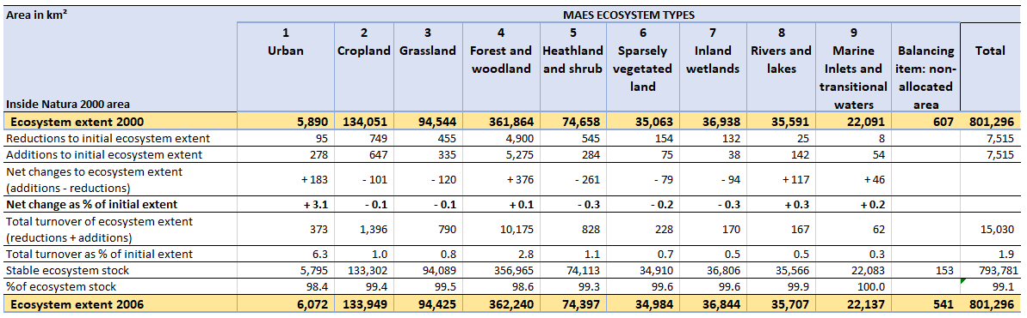

Table .: Tier I Ecosystem Extent Account for Natura 2000 network, EU-27 + UK countries, 2006 - 2012.

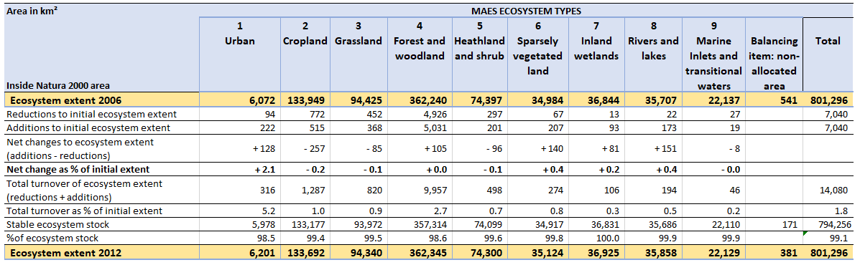

Table .: Tier I Ecosystem Extent Account for Natura 2000 network, EU-27 + UK countries, 2012 - 2018.



From a policy perspective it is useful to compare Ecosystem Extent Accounts for the Natura 2000 network against matching extent accounts for the EU area outside of the Natura 2000 network. This can identify fundamental differences in ecosystem composition between these areas and whether the Natura 2000 designations are associated with limited net changes (or turnovers and stability) in ecosystem extent. To this end, Table 4.5 to Table 4.7 present Tier 1 Ecosystem Extent Accounts for the rest of the EU-27 + UK (i.e., the Non-Natura 2000 area within the EU-27 + UK, comprising 3,597,937 km2) for the 2000 to 2018 period.

Collectively, Table 4.2 to Table 4.7 reveal that the turnover of Forest and woodland ecosystems is considerably higher outside of the Natura 2000 network between 2000 and 2006 (6.3%); 2006 and 2012 (9.8%); and, 2012 and 2018 (7.0%), compared to inside the network where the turnover is about 2.8% across the three accounting periods. For Grassland, Heathland and shrub and Sparsely vegetated land ecosystems, the turnover is also much higher outside of the Natura 2000 network, albeit a variation between 1.0% and 1.5% across the accounting periods.

Table .: Tier I Ecosystem Extent Account for area outside Natura 2000 network, EU-27 + UK countries, 2000 - 2006.

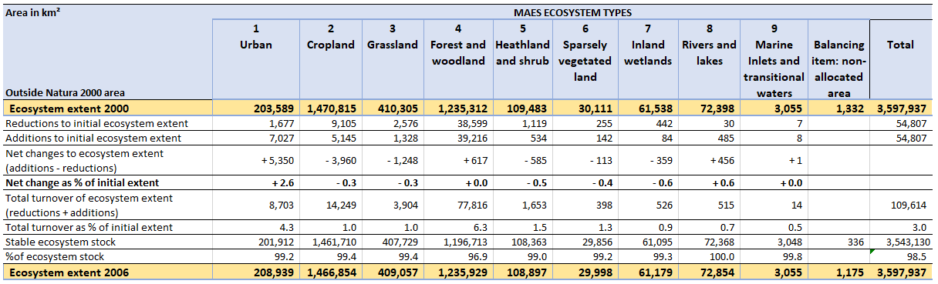

Table .: Tier I Ecosystem Extent Account for area outside Natura 2000 network, EU-27 + UK countries, 2006 - 2012.

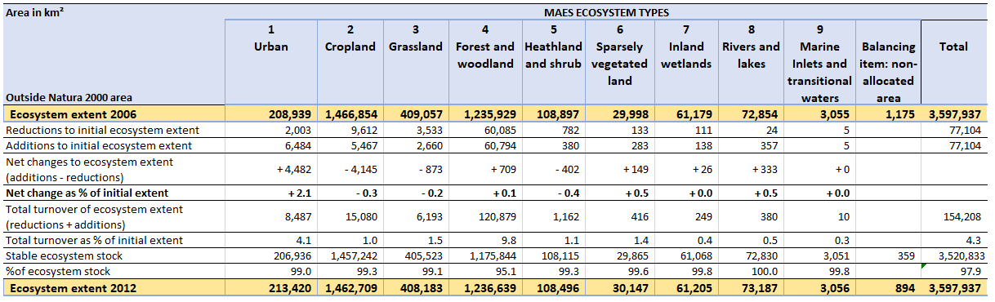

Table .: Tier I Ecosystem Extent Account for area outside Natura 2000 network, EU-27 + UK countries, 2012 - 2018.

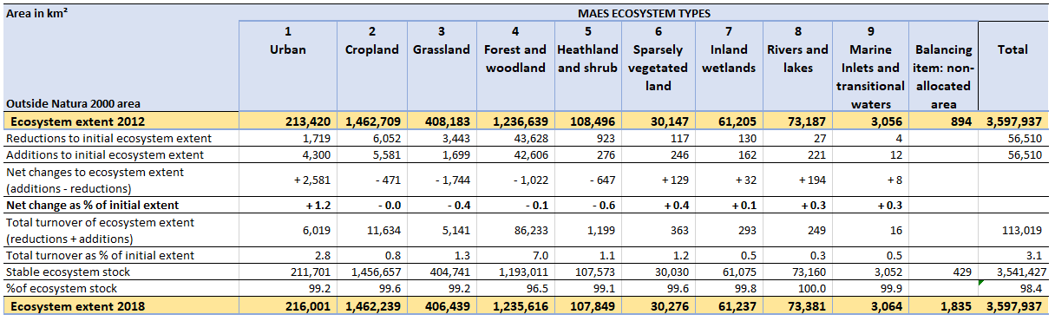

Table 4.7 reveals that Cropland ecosystems are the most common ecosystems in areas of the EU-27 + UK outside of Natura 2000 areas (i.e., the rest of the EU-27 + UK area). In order to allow ready comparison, Figure 4‑1 provides the composition of ecosystem types within the Natura 2000 network. This can be compared with Figure 4‑2, which presents the composition of ecosystem types within the remainder of the EU-27 + UK area i.e., outside the Natura 2000 network.

Comparison of Figure 4‑1 and Figure 4‑2 reveals substantial differences with respect to the proportion of Urban, Cropland and Forest and woodland ecosystems extent. Inside the Natura 2000 network, Urban and Cropland ecosystems represent 1% and 17% of the total ecosystem extent, whereas in the rest of the EU-27 + UK area this increases to 6% and 41%, respectively. Forest and woodland ecosystems represent 45% of the ecosystem extent inside Natura 2000 areas, compared to 34% in areas outside the Natura 2000 network. Grassland ecosystems comprise 11% to 12% of total ecosystem extent in both areas. However, the proportion of Heathland and shrub, Sparsely vegetated land, Inland wetlands, Rivers and lakes and Marine inlets and transitional waters is around three times higher in the Natura 2000 network.

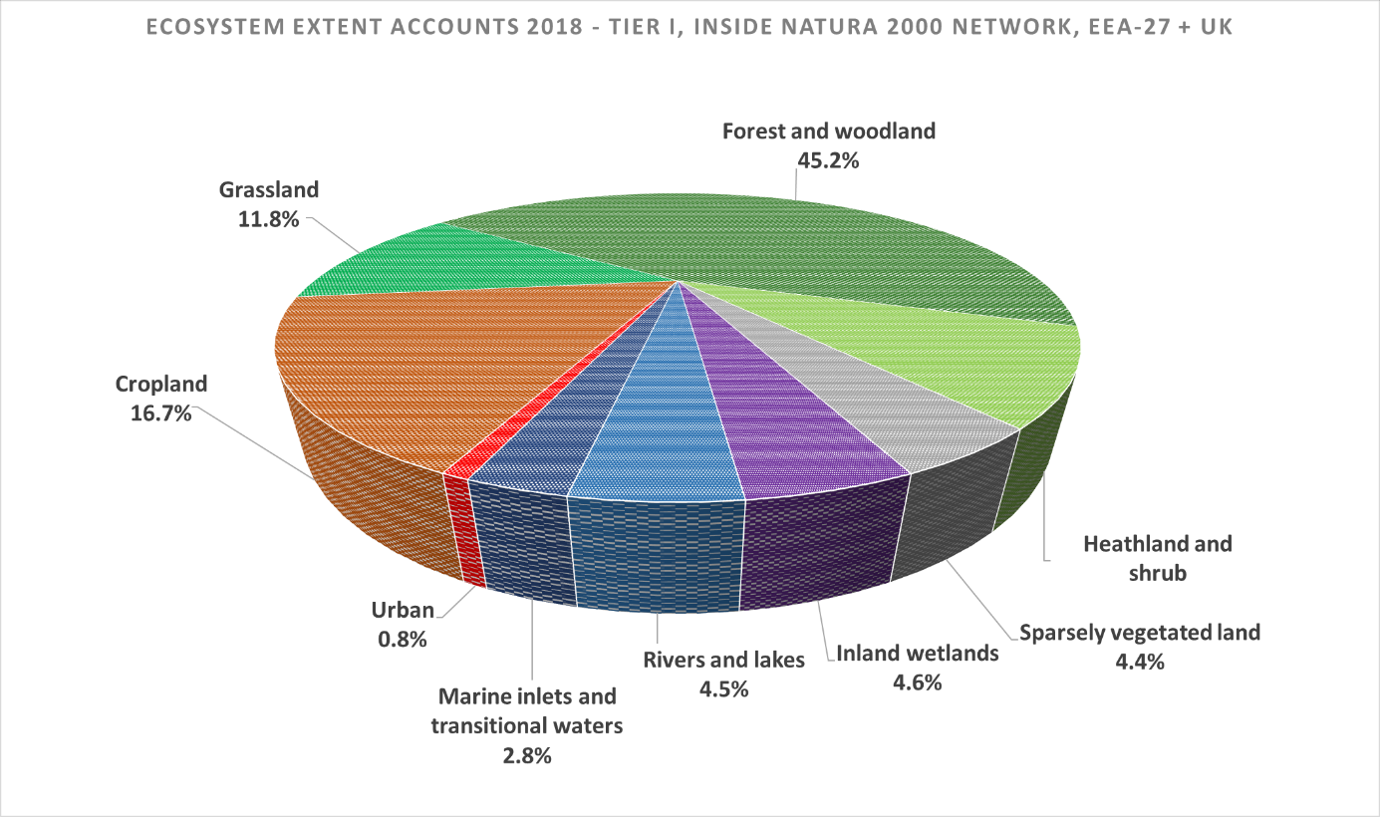

Figure ‑: Percentage of MAES ecosystem type for area inside Natura 2000 network, EU-27 + UK countries, 2018.

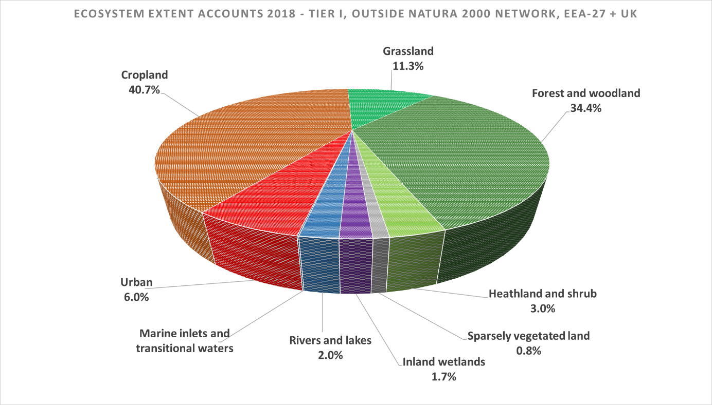

Figure ‑: Percentage of MAES ecosystem type for area outside Natura 2000 network, EU-27 + UK countries, 2018.

It is highlighted that the total extent accounting for within the Natura 2000 network (801,296 km2), plus the extent accounting for outside the network (3,597,937 km2), matches the total extent reported in Table 3.4 to Table 3.7 (4,399,233 km2, subject to a small rounding error). This demonstrates that the Ecosystem Extent Accounts conducted within and outside the Natura 2000 areas, as well as those for the EU 27 + UK area as a whole, are internally consistent. Interestingly, comparison of Figure 4‑1 and Figure 4‑2 suggests that almost the entire extent of the Marine and transitional waters in the Tier I Ecosystem Extent Accounts for the EU 27 + UK area are part of the Natura 2000 Estate.

Figure 4‑3 summarises the information on relative changes in ecosystem extent between areas inside and outside of the EU-27 + UK Natura 2000 network. Figure 4‑3 clearly indicates that reductions in extent of the semi-natural ecosystem types Grassland, Heathland and shrub and Inland wetlands are lower within the Natura 2000 areas. This is also the case for Cropland. Nonetheless, Figure 4‑3 also shows that the extent of all these ecosystems has still declined (possibly not a concern for Cropland), followed by an increase in the extent of Urban, Sparsely vegetated land and Rivers and lakes ecosystems. With the exception of Urban ecosystems, it appears that ecosystems tend to be more stable within Natura 2000 areas (i.e., net changes are closer to zero), as expected.

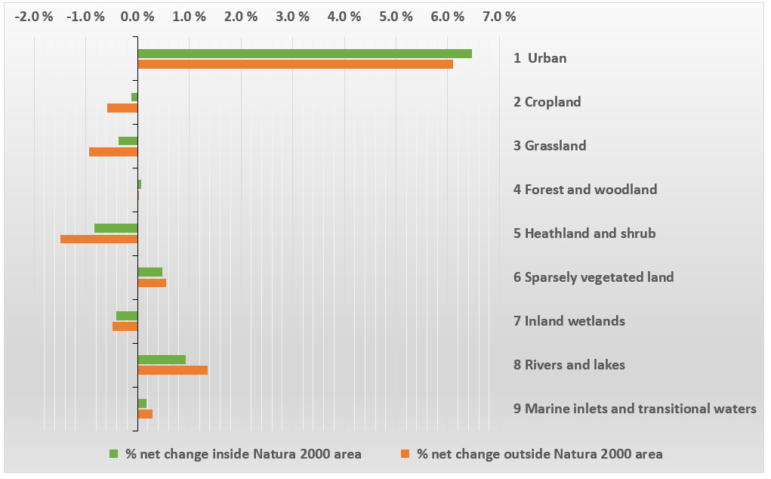

Figure ‑: Net changes in ecosystem extent for areas inside and outside Natura 2000 network, EU-27 + UK countries, 2000 – 2018.

Generally, protected sites in the Natura 2000 network show lower rates of ecosystem change than the area outside the network, which indicates a higher degree of ecosystem stability inside the network of EU protected areas. While the increase of Urban area within the Natura 2000 network is higher than outside, this difference remains small. Furthermore, the opening extent of the Urban ecosystem type inside Natura 2000 area represents only 5,890 km2 in 2000 (Table 4.2) compared to an opening stock of 203,589 km2 outside it (Table 4.5). This implies that the increase of the Urban ecosystem type inside the Natura 2000 network was substantially smaller in absolute area terms (i.e. total km2) than outside.

# Tier II Ecosystem Extent Trends and Accounts

The Tier II accounts allow for a more detailed analysis of trends in the extent of a selected set of MAES ecosystem sub-types. This, in turn, improves the analytical power of the accounts and can support the Tier I accounting results by compiling Ecosystem Extent Accounts that are better aligned with specific ecosystem sub-types. This includes gaining an understanding of the internal transformations (i.e., transfers flows from one Tier II ecosystem type to a different Tier II type, where types are nested within the same Tier I type). It also allows for a more focused analysis by compiling Ecosystem Extent Accounts for smaller groupings of CLC level 3 classes that are better aligned with specific ecosystem sub-types relevant to policy priorities, such as biodiversity conservation and ecosystem services delivery. Figure 5‑1 gives an overview of the Tier II ecosystem extent in 2018 for the EEA-38 + UK area.

A summary of the key results from the Tier II Ecosystem Extent Accounts is provided in Box 5.1.

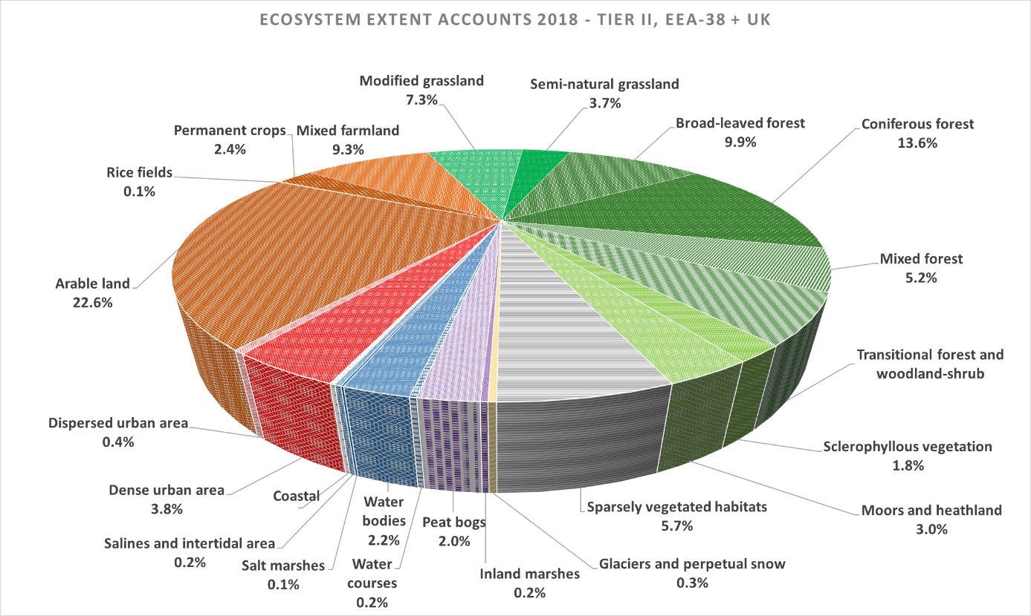

Figure ‑: Tier II ecosystem extent, EEA-38 + UK countries, 2018.

Box ‑: Key results from the analysis of Tier II Ecosystem Extent Accounts for the 2000 to 2018 period (EEA-38 + UK countries).

* The extent of natural and semi-natural ecosystems has decreased in the EEA-39 between 2000 and 2018 although this decrease remains below 1% for the accounting period for all tier II ecosystem categories, except for Sclerophyllous vegetation (-2.0%) and Glaciers and perpetual snow (-5.5%).
* Decreases in the extent of Heathland and shrub observed in the Tier I Ecosystem Extent Accounts are driven by decreases in the extent of the category Sclerophyllous vegetation.
* Decreases in the extent of Peat bogs are driving the loss of Inland wetlands observed within the Tier I Ecosystem Extent Accounts.
* The increase in Rivers and lakes ecosystems observed in the Tier I Ecosystem Extent Accounts is due to increases in the extent of Inland water bodies (supporting the assumption this is associated with reservoir construction, or similar). Whereas the extent of Inland water courses shows a decline.
* Within the Tier I Marine inlets and transitional waters ecosystem type, Salines and intertidal areas show an increase in extent (possibly linked to salt production or nature restoration activities).
* The Tier II Ecosystem Extent Accounts reveal that the relative stability in extent of Sparsely vegetated land observed at Tier I masks relatively large decreases in the extent of Glaciers and perpetual snow. The reductions in this ecosystem category are largely compensated by increases in Sparsely vegetated habitats.
* The high turnover in the extent of Forest and woodland ecosystems observed in the Tier I accounts is likely to be due to internal transformations between Transitional woodland and shrub and forest land cover resulting from harvesting cycles.

## Tier II Ecosystem Extent Accounts for natural and semi-natural MAES ecosystems (EEA-38 + UK)

Tier II Ecosystem Extent Accounts for those Tier II classes representing natural or semi-natural areas that may be of importance for biodiversity are presented in Table 5.1 for the EEA-38 + UK area.[10] For example, different forest types, moors and heath, sparsely vegetated habitats, inland marshes, water courses and salt marshes flats. These are organised by MAES ecosystem type in Table 5.1. Inspection of Table 3.1, Table 3.2 and Table 3.3 shows that the opening and closing extents of the MAES terrestrial ecosystem types match those presented in Table 5.1 for 2000, 2006, 2012 and 2012, demonstrating that these accounting tables are consistent.

A key result from Table 5.1 is that the extent of natural and semi-natural ecosystems has decreased in the EEA-38 + UK area between 2000 and 2018 (-0.2%, or 7,189 km2). With respect to Table 2.2, a high degree of confidence is attributed to this trend. Table 5.1 also reveals that the largest changes in Tier II ecosystem extent are associated with the forest types. This is discussed in detail in Section 5.2.

From Table 5.1 it can be observed that the extent reduction of Heathland and shrub at the European scale is driven by a decrease in the extent of Sclerophyllous vegetation (the opening extent of 110,009 km2 decreases by 2.0%, or -2,147 km2, between 2000 and 2018). In some areas this trend may represent a significant environmental concern. For example, in the Iberian Peninsula the Worldwide Fund for Nature (WWF) identify that the loss of this type of vegetation is reducing habitat for Iberian lynx (*Lynx pardinus*), the Spanish imperial eagle (*Aquila heliaca*), and the great bustard (*Otis tarda*) (WWF, n.d.). However, it is also noted that Moors and heathland show consistent reductions in extent between 2000 and 2018 (-0.4%, or -688 km2), as well as Inland marshes (-0.2%, or -23 km2) and Peat bogs (-0.5%, or -545 km2). With respect to the reductions in Inland wetlands at the European scale discussed in Section 3.1 (Figure 3‑1), the main factor is the downward trend in Peat bogs extent.

For Rivers and lakes, Table 5.1 shows that the extent of Water courses declined by 0.7% (or 93 km2) between 2000 and 2018, from an opening extent of 13,429 km2. Conversely, the extent of Water bodies shows an increase of 1.7% (2,242 km2) associated with an opening extent of 127,217 km2. This supports the conclusion drawn with respect to Figure 3‑1, i.e. that the increase in Rivers and lakes ecosystem extent is mainly due to new artificial lakes and reservoirs. This is likely to be a result of hydrological dams, infrastructure development and mineral extraction activities (EEA, 2010).

Within the Marine inlets and transitional waters ecosystem type, increases in the extent of Salines and intertidal areas (+0.5%, or 67 km2) and Salt marshes (+0.6%, or 35 km2) are also observed between 2000 and 2018. The increase in the extent of Salines and intertidal areas may by indicative of localised expansion of sea salt production activities.

Table 5.1 also confirms the stability in the extent of Sparsely vegetated land observed at the European scale in Figure 3‑1 for this MAES ecosystem type. Whilst small in absolute terms, large relative reductions are observed in the extent of Glaciers and perpetual snow (-5.5%, or -853 km2). This may reflect the retreat of glaciers attributed to increasing summer temperatures in Europe (EEA, 2016a). The rate of glacier mass loss has markedly increased in specific areas since 2000 (e.g., France, EEA, 2016a). This reduction of extent is offset by a similar increase in the extent of Sparsely vegetated habitats between 2000 and 2018 (+0.2%, or +655 km2).

Table .: Tier II ecosystem extent trends for natural and semi-natural CLC Classes by MAES ecosystem type, EEA-38 + UK countries, 2000 – 2018.



## Tier II Ecosystem Extent Accounts for forest ecosystems (EEA-38 + UK)

As Table 5.1 shows, the relative change in the extent of Forest and woodland ecosystem type between 2000 and 2018 in the EEA-38 + UK is negligible. However, as reported in Table 3.1, Table 3.2 and Table 3.3, this ecosystem types appears to have the highest ecosystem extent turnover, with 4.9% of the extent in 2000 either being converted to a different ecosystem type or undergoing an internal transformation between 2000 and 2006 (equivalent to 98,123 km2). This figure increases to 7.0% between 2006 and 2012 (equivalent to 140,590 km2), and falls back again to 5.3% between 2012 and 2018 (equivalent to 106,733 km2).

The narrower typology underpinning the Tier II Ecosystem Extent Accounts can provide an insight into what is driving these transformations. As Table 5.1 shows, internal conversions explain a large proportion of the turnover within the MAES Forest and woodland ecosystem type, notably due to a reduction in the extent of Coniferous forest and an increase in the extent of Transitional woodland-shrub. Figure 5‑2 summarises the accounted gross additions and reductions to forest ecosystems extent by CLC level 3 within the EEA-38 + UK between 2000 and 2018.[11]



Figure ‑: Change in Forest and woodland extent by CLC Level 3, EEA-38 + UK countries, 2000 – 2018.

Figure 5‑2 illustrates that the total reductions in Broad-leaved and Coniferous (approximately -93,000 km² in aggregate) exceed total additions for these ecosystems (approximately +50,000 km²). This results in a reported net loss in the extent of these ecosystems of approximately -43,000 km2, largely associated with loss of Coniferous forest.

In contrast, the extent of Transitional woodland-shrub shows a net increase of approximately +35,500 km². This is believed to reflect internal transformations arising from the forestry management cycle, which involves felling and replanting of trees, leading to land cover resembling Transitional woodland-shrub. Consequently, the increase of +10.7% in Transitional forest and woodland-shrub between 2000 and 2018 reported in Table 5.1 is unlikely to be sustained in the long-term due to regrowth during the course of the forest harvesting cycle. This also implies that the reported reduction in the extent of Coniferous forests (-4.6%) and Broad-leaved forests (-1.1%) provided in Table 5.1 may rebound over the long term or be offset by more mixed forest planting. Figure 5‑2 also reveals that mixed forest shows a relatively large increase in extent between 2000 and 2018, increasing by approximately 7,500 km2 over this period.

The reduction in the extent of Transitional forest and woodland-shrub ecosystems between 2006 and 2012 reported in Table 5.1 provides some evidence to support that forest harvesting cycles are driving the internal conversions observed in the Tier II Ecosystem Extent Accounts. Some smaller increases in the extent of Transitional forest and woodland-shrub may also be explained by changes in land management, including the abandonment of marginal farmlands. Unused open Grasslands (including pastures) may decline due to natural forest regeneration and afforestation.

# Tier III Ecosystem Extent Accounts (EEA-38 + UK)

The detailed spatial data set that Corine Land Cover provides is very flexible and allows analysis of ecosystem data at different ecological resolutions, and for different geographic units (i.e., Ecosystem Accounting Areas). Chapter 5 demonstrated that more refined ecological insights can be achieved by disaggregating the Tier I Ecosystem Extent Accounts using the more detailed typology of Tier II. Tier III provides the opportunity for further disaggregation and more detailed analysis for some ecosystem categories. A summary of the key results from the Tier III Ecosystem Extent Accounts is provided in Box 6‑1.

Box ‑: Key results from the analysis of Tier III Ecosystem Extent Accounts for the 2000 to 2018 period (EEA-38 + UK countries).

* Within the Tier I Urban ecosystem type large increases in the extent of mineral extraction sites (23%) and Open green spaces (7%) are observed over the 2000-2018 accounting period.
* While most cropland sub-categories decline in extent the area of Permanent crops has increased, in particular that of Olive groves (3% from 2000-2018).
* The ecosystem sub-category of Agro-forestry has remained stable throughout the period observed.
* A small but significant decrease in the extent of Semi-natural grassland (-0.7%) is observed.
* A significant increase in the extent of Salines (7%) is reported between 2000 and 2018.

Table 6.1 summarises the Tier III Ecosystem Extent Accounts for the EEA-38 + UK area for 2000 to 2018.[12] The discussion below only focuses on the Tier III Ecosystem sub-categories that are distinctive from the Tier II Ecosystem types. Table 6.1 shows that there have been relatively large increases in the extent of Mineral extraction sites between 2000 and 2018 (+23%, equivalent to an annual increase of 1.3%). In addition, within the Tier II Dispersed urban area ecosystem category, large increases can be observed for the Open green space between 2000 and 2018 (+7.3%, equivalent to an annual increase of 0.4%). This may reflect urban planning approaches to develop more open green spaces in cities. Alternatively, it may be an artefact of reduced density in urban expansion at municipal fringes.

The Tier III Ecosystem Extent Accounts can also provide information about specific ecosystems of policy and management interest. Agro-forestry ecosystems are a good example, as they represent traditional, low-intensity land use that have created habitats of high biodiversity and landscape value within the broader Tier I MAES Cropland and Tier II Mixed farmland ecosystem types. They are also an important part of High Nature Value farmland, and substantial parts of Agro-forestry areas are protected by Natura 2000 designations. Agro-forestry is assigned its own CLC Level 3 class (244) because of its distinctive land cover characteristics of trees mixed with cropping and/or grazing land use. As also shown in Table 6.1, the extent of Agro-forestry ecosystems has remained relatively stable across 2000, 2006, 2012 and 2018.

Table .: Tier III Ecosystem Extent Accounts, EEA-38 + UK countries, 2000 – 2018.



With respect to the semi-natural and natural Tier II ecosystem categories, Table 6.1 reveals small but consistent losses of Semi-natural grassland between 2000 and 2018. Overall, the extent of this ecosystem sub-category reduced by -0.7% (or 1,502 km2) over this time period. Based on the thresholds set out in Table 2.2, a high confidence is attributed to this trend.

Table 6.1 shows relatively large increases in the extent of Salines (+7.2%, equivalent to an annual increase of 0.4%). Whilst this increase is small in absolute terms, the trend is providing an important contribution to the overall increases in Salines and intertidal areas observed in the Tier II Ecosystem Extent Accounts. This could be due to an increased interest in sea salt production of the effect of nature restoration activities.

Within the Tier II ecosystem category of Sparsely vegetated habitats, a relatively large increase in the extent of Bare Rocks is observed between 2000 and 2018 (+0.7%). Within this same Tier II category, increases in the extent of Beaches, dunes and sands are also noted (+1.1%). Both of these increases exceed the threshold confidence levels proposed in Table 2.2.

# Synthesis of results

This report presents the first set of Ecosystem Extent Accounts for the EEA-38 + UK and EU-27 + UK areas for the accounting periods 2000 to 2006; 2006 to 2012; and, 2012 to 2018. The accounts have been compiled using both the MAES Ecosystem Typology (Tier I) and further disaggregated to Tier II and III Ecosystem Typologies derived for Corine Land Cover (CLC) Level 3 classes. Due to the flexible nature of the spatial data sets employed to compile the accounts, it has been possible to organise the accounts to analyse various geographic, ecosystem and policy themes. This includes analysis of ecosystem extent and trends at the European scale, by biogeographic region and for the Natura 2000 network of protected areas, as well as exploring the impacts of urbanisation and the dynamic nature of Forest and woodland ecosystems. This chapter provides a synthesis of these results.

## Analysis of Ecosystem Extent in Europe (EEA-38 + UK and EU-27 + UK)

For both the EEA-38 + UK and EU-27 + UK areas, the Tier I Ecosystem Extent accounts reveal that Urban ecosystems increased the most in relative extent, in excess of 2.5% between 2000 and 2006 and over 2% in 2006 and 2012, followed by a lesser increase of just over 1% between 2012 and 2018. The ecosystem type Rivers and lakes also showed increases in extent, particularly within the EEA-38 + UK area (1.5% between 2000 and 2018).

The largest relative losses between 2000 and 2018 were observed for Heathland and shrub in the EEA-38 + UK (-1.0%) and the EU-27 + UK (-1.2%). The Tier I Ecosystem Extent Accounts also revealed reductions in the extent of Grassland (-0.9% in the EEA-38 + UK and -0.8% in the EU-27 + UK) and Inland wetlands (-0.4% in the EEA-38 + UK and -0.5% in the EU-27 + UK). Ongoing loss of Cropland is revealed in both the EU-27 + UK and EEA-38 + UK areas. Whilst this is small in relative terms (-0.5% between 2000 and 2018), it is still large in absolute terms (-10,111 km2 in the EEA-38 + UK).

Overall, the Tier I Ecosystem Extent Accounts reveal that ecosystems extent in Europe is generally stable, with approximately 99% of the stock of ecosystems remaining unchanged over each of the 2000 to 2006; 2006 to 2012; and, 2012 to 2018 accounting periods. The notable exception was for Forest and woodland ecosystems, where the highest rates of ecosystem turnover (gross changes as a % of opening extent) were observed (up to 7.0% between 2006 and 2012 in the EEA-38 + UK area).

The Tier II Ecosystem Extent Accounts provide further insight into the nature of the additions, reductions and turnover in ecosystem extent as they provide information on the changes in land cover related to specific MAES ecosystem sub-types. Figure 6.1 summarises the relationship between the Tier I and II Ecosystem Extent Accounts and the trends they reveal for the EEA-38 + UK area between 2000 and 2018. The confidence in these trends is characterised using the thresholds set out in Table 2.2.

The Tier II and Tier III ecosystem extent trends in Figure 7‑1 focus only on the natural or semi-natural ecosystems types within the parent MAES ecosystem type. This is because of their importance for biodiversity conservation and ecosystem services. Figure 3‑1 shows that Cropland area is decreasing in the EEA-38 + UK, although Figure 7‑1 illustrates that Agro-forestry (a Tier III Ecosystem Type) remains stable. However, for Grasslands reductions in extent in the Tier I accounts are also mirrored by Tier III trends in the reduction of semi-natural Grasslands.

|  |  |
| --- | --- |
|  |  |
|  |  |

Figure ‑: Overall trends for semi-natural Tier II and III ecosystem types, EEA-38 + UK countries, 2000 – 2018.

A review of results for Tier II Ecosystem Extent trends identifies that the decrease in the extent of inland wetland ecosystems in Europe is driven by loss of peat bog between 2000 and 2018 (as shown in Figure 7‑1). The decreases in the extent of Heathland and shrub observed for Europe are found to be driven by decreases in the extent of Sclerophyllous vegetation. Figure 7‑1 also reveals that the reduction in the extent of Inland wetlands is driven by reductions in the extent of peat bogs.

An analysis of the Tier II extent trends show the increase in the extent of the MAES ecosystem type Rivers and lakes shows this is driven by increases in the extent of water bodies, rather than water courses (as shown in Figure 7‑1). This supports the assertion that the increase in the extent of this ecosystem can likely be attributed to infrastructure development, such as dams and reservoirs. It also allows for this to be quantified, the extent of water bodies was found to increase by 2,242 km2 between 2000 and 2018 in the EEA-38 + UK area.

For Forest and woodland ecosystems, the Tier II ecosystem extent trends suggest that part of the high turnover rates observed may be explained by forest management cycles, which involves felling and replanting of trees, leading to land cover resembling the Transitional woodland-shrub CLC class as Broad-leaved and Coniferous trees are felled. In addition, some of the increase in the extent of the forest MAES ecosystem type may be attributable to increases in Transitional woodland-shrub due to natural regeneration following abandonment of marginal farmlands. For Agro-forestry, the Tier III accounts reveal that this type of ecosystem exhibits a small reduction in extent in Portugal but a slight increase in Spain and Europe overall.

The Tier I Accounts indicate that the extent of Marine inlets and transitional waters is stable at the level of the MAES ecosystem typology. However, Tier II and Tier III trends suggest that there may be increases in extent of Salines and Salt marsh sub-ecosystem types. Within the MAES ecosystem type of Sparsely vegetated land, examination of the Tier III Ecosystem Extent trends reveals the reductions in Glaciers and permanent snow are found to be associated with increases in bare rock and beaches, sands and dunes extent. This may reflect wider evidence of climate change impacts on glaciers in Europe.

## Analysis of Ecosystem Extent by Biogeographical Region (EEA-38 + UK)

Biogeographical regions represent an example of geographical areas of policy interest, including under the EU Habitats Directive. Due to the flexible nature of the spatial infrastructure employed to compile the accounts, it has been possible to calculate Ecosystem Extent Accounts for these accounting areas. These Tier I Ecosystem Extent Accounts reveal:

* Relatively high rates of urban expansion were observed in biogeographical regions with large coastal areas (e.g., Mediterranean and Black Sea).
* Increases in the extent of Rivers and lakes ecosystems in Europe is driven by increases in the Mediterranean biogeographical region.
* The reduction in Heathland and shrub extent in Europe is driven by reductions in extent in the Mediterranean biogeographical region.
* The highest rates of Grassland loss were observed in the Boreal biogeographical region.
* The reduction in Inland wetland extent in Europe is driven by reductions in extent in the Atlantic biogeographical region.

## Other Policy applications

The basic and flexible structure of the Ecosystem Extent Accounts allows for a multitude of analytical assessments. This feature facilitates the application of ecosystem accounting results to different kinds of decision-making processes and also as input to strategic planning activities for the management of natural capital in the EU.

Due to the growth of urban populations and urban areas, land occupied by man-made surfaces and dense infrastructure networks has increased, connecting human settlements and fragmenting landscapes and natural areas. This urban development is accelerated by a positive feedback mechanisms as new transport infrastructure routes typically accompany urban sprawl. This, in turn, requires even more technical infrastructure that further increases fragmentation of landscape and ecosystems (EEA, 2010). The spatial data grid developed for the extent accounts allows an analysis of the impacts of this on other ecosystems. This reveals that Cropland is the main ecosystem converted to urban land use in Europe (accounting for over 60% of urban sprawl). However, differences emerge across Member States, for instance forests are the main ecosystem converted to urban land use in the Nordic countries and it was Grassland in Ireland.

The type of information discussed above highlights which ecosystems in which areas are being lost to urban sprawl. Whilst Cropland is the main ecosystem converted to urban land-use, the accounts also allow an analysis of impacts on other ecosystem types. This includes the narrower ecosystem typologies that can be targeted via the Tier II and III accounts. Whilst not presented here, this information can help set priorities for protection of natural capital, as many semi-natural ecosystems in landscapes with high levels of urbanisation are likely to deliver ecosystem services important to a large number of beneficiaries (e.g., recreation services, air pollution regulation).

The Tier I Ecosystem Extent Accounts for the Natura 2000 network revealed that the extent of the (semi-) natural ecosystems Forests and woodland, Heathland and shrub, Sparsely vegetated land, Inland wetlands and Marine inlets and transitional waters is, relatively, higher in Natura 2000 areas compared to the rest of the EU-27 + UK. Conversely, the extent of Cropland and Urban ecosystems is relatively higher outside of the Natura 2000 network. The relative extent of Grassland was very similar inside and outside of the Natura 2000 network. Forest, Grassland, Heathland and shrub and Sparsely vegetated land ecosystems were also exhibited lower rates of turnover in Natura 2000 areas. Nonetheless, with the exception of Rivers and lakes and Forest and woodland, losses in the extent of (semi-)natural ecosystems were also observed in Natura 2000 areas (albeit at slower rates than outside of these areas). With the exception of urban areas, ecosystems within the Natura 2000 network also exhibited relatively lower net changes in extent. This suggests that ecosystems are generally more stable in extent in Natura 2000 areas.

# Review and outlook

## Review of current work and analytical options

This report demonstrates that it is possible to compile ecosystem extent accounts for the full extent of the terrestrial area of Europe. These accounts allow monitoring trends in the extent and distribution of major European ecosystem types via three nested sub-divisions of increasing ecological detail. The outputs from this work can be utilised to understand which ecosystem types suffer losses in extent and/or distribution to target policy responses on vulnerable elements of Europe’s natural capital so it continues to provide future benefits for all.

Focusing the accounting approach on trends in specific ecological or management units is important for the overall analytical value of ecosystem extent accounting. For instance, this can support assessment of nature conservation efforts under the Nature Directives (i.e., the Habitats and Birds Directives). Integrating the Tier I Ecosystem Extent Accounts with WFD river basin units or assessments by biogeographical regions are other examples of such analytical focus.

Given existing work by the EEA (2015) to associate habitats and species with Tier I ecosystem types (aligned with the MAES ecosystem classification), the broad implications of ecosystem loss potentially be evaluated from a species or habitat perspective. However, given the relative stability in ecosystem types encountered within the Tier I Ecosystem Extent Accounts, the Tier II and III Ecosystem Extent Accounts may provide a better indication of the impacts of land cover/use change on species. Van Kleunen (2003) provides a useful note for associating species with Corine Land Cover classes at CLC level 3 that could also support such analysis.

The calculation of the accounts presented in this report relies on the EEA Integrated Data Platform (EEA IDP, presented in section 2.2) which enables an efficient, semi-automatic production of ecosystem extent and land accounts. Integrating further data sets into the same geo-spatial infrastructure would provide an opportunity for relating different SEEA EEA accounting modules, such as Ecosystem Condition Accounts and Ecosystem Service Accounts, to the same spatial units. Combining these different types of SEEA accounts (developed under the KIP-INCA project for the EU) in one geo-spatial platform would enable an integrated spatial analysis of connections between these ecosystem accounts. Furthermore, a general insight into the benefits associated with the current configuration of ecosystem assets in Europe could be gained using a matrix based approach to link ecosystem types and expert assessments of service provision (e.g., Jacobs et al., 2015).

The Tier I to III Ecosystem Extent Accounts have been calculated using the Corine Land Cover data. These land cover classes align well with ecosystem types in some cases, particularly at the disaggregated Tier II and Tier III scale. However, the Corine Land Cover Data is only one of a number of earth observation products produced via the Copernicus Land Monitoring Service in EEA.[13] These additional products offer some possibilities for incorporating additional detailed information for certain ecosystem types. For example, the High Resolution Layers (HRLs) for Riparian Zones and Urban Areas may improve the thematic resolution of ecosystems extent accounting for these types of areas.

Integrating different ecosystem accounting data sets in geo-spatial analysis provides one route for developing more analytical value from the current investment into ecosystem accounts at EU-level. Further options for development lie in improving the geometric precision of underpinning (land cover) data sets as well in thematic refinement, i.e. adding further ecological sub-divisions.

## Outlook

The further development of the European approach to producing Ecosystem Extent Accounts is likely to focus on two different aspects: a) utilising improvements in the available data foundation, in particular via the EU Copernicus programme, and b) expanding and refining the tiered approach for ecosystem accounts proposed by the EEA. The timeline for the first aspect is set by the release schedule of future products under the EU Copernicus programme and other ecosystem monitoring programmes; the timeline for the second aspect depends on available capacity to develop and implement changes in the current ecosystem extent accounts.

The current set of extent accounts is based on the Corine Land Cover (CLC) data set. This will be replaced by the CLC+ data set from which is scheduled to be delivered by the Copernicus land services every three years and offers more spatial detail than the current CLC data set. It will provide a high resolution mapping CLC product (1 ha) with a 2018 baseline. As well as this European scale land cover product, CLC+ will also provide a multifunctional 1ha geospatial dataset integrating a high level of thematic detail using various HRLs and Very HRLs. This will allow the range of high to very high resolution layers currently being produced to be more readily integrated with data on land cover, as well as supporting the development of higher spatial resolution ecosystem extent accounts. A slightly simplified version of the CLC product will also continue to be produced at the current 25ha minimum mapping unit, ensuring a time series to support Ecosystem Extent Accounting in Europe.

The EEA is also working on developing spatial data sets that combine land cover and biodiversity data sets via the European ecosystem map (EEA, 2019b; Weiss & Banko, 2018). In this regard, incorporating geo-referenced data on vegetation type and structure would be particularly helpful for improving the thematic representation of ecosystems in mapping products. Understanding land use will also be critical to improving this thematic resolution, helping to distinguish similar land cover types that are clearly very different ecosystems (e.g., golf courses from (semi-)natural Grasslands). The forthcoming Copernicus high resolution product on phenology is expected to be very useful for identifying several different grassland land use types (e.g. meadows via mowing frequency or golf courses via their very stable signal).

Future Ecosystem Extent Accounts should also include the main European marine ecosystem types. The integration of this dimension is currently hampered by lack of suitable spatial data for marine ecosystem types, as well as conceptual challenges due to the three-dimensional nature of marine ecosystem types.

# References

Bogaart, Patrick (2021). Personal communication on 18 February 2021.

Council of Europe. (1979). *Convention on the Conservation of European Wildlife and Natural Heritage. Bern, Switzerland*. Retrieved from https://www.coe.int/en/web/conventions/full-list/-/conventions/treaty/104

EC. (n.d.). Natura 2000 sites designation. Retrieved June 4, 2019, from https://ec.europa.eu/environment/nature/natura2000/sites/index_en.htm

EC. (1992). *Habitats Directive 92/43/EEC of 21 May 1992 on the conservation of natural habitats and of wild fauna and flora*. Retrieved from https://eur-lex.europa.eu/legal-content/EN/TXT/?uri=CELEX:31992L0043

EC, & EEA. (2016). *Report on phase 1 of the knowledge innovation project on an integrated system of natural capital and ecosystem services accounting in the EU (KIP-INCA Phase 1 report)*. Retrieved from http://ec.europa.eu/%0Aenvironment/nature/capital_accounting/pdf/KIP_INCA_%0Afinal_report_phase-1.pdf

EEA-FOEN. (2016). *Urban sprawl in Europe* (No. EEA Report No 11/2016). Retrieved from https://www.eea.europa.eu/publications/urban-sprawl-in-europe/download

EEA. (2002). *Europe’s biodiversity - biogeographical regions and seas*. Retrieved from https://www.eea.europa.eu/publications/report_2002_0524_154909

EEA. (2006a). *Land accounts for Europe 1990-2000 — toward integrated land and ecosystem accounting* (No. EEA Report No 11/2006).

EEA. (2006b). *The thematic accuracy of Corine land cover 2000: Assessment using LUCAS (land use/cover area frame statistical survey)* (No. EEA Technical report No 7/2006). Retrieved from https://www.eea.europa.eu/publications/technical_report_2006_7

EEA. (2010). *The European Environment State and Outlook 2010: Land use*. Retrieved from https://www.eea.europa.eu/soer/europe/land-use

EEA. (2015). *Linkages of species and habitat types to MAES ecosystems*. Retrieved from https://www.eea.europa.eu/data-and-maps/data/linkages-of-species-and-habitat

EEA. (2016a). Glaciers Indicator Assessment (CLIM 007). Retrieved October 4, 2019, from https://www.eea.europa.eu/data-and-maps/indicators/glaciers-2/assessment

EEA. (2016b). Urban sprawl dataset. Retrieved October 4, 2019, from https://www.eea.europa.eu/data-and-maps/data/external/urban-sprawl-2016

EEA. (2019a). Corine Land Cover Accounting Layers. Retrieved September 19, 2019, from https://www.eea.europa.eu/data-and-maps/data/corine-land-cover-accounting-layers

EEA. (2019b). Ecosystem types of Europe. Retrieved October 4, 2019, from https://www.eea.europa.eu/data-and-maps/data/ecosystem-types-of-europe-1

EEA. (2019c). Natura 2000 data - the European network of protected sites. Retrieved October 4, 2019, from https://www.eea.europa.eu/data-and-maps/data/natura-10

EEA (2020). [Land cover accounts – an approach to geospatial environmental accounting](https://www.eea.europa.eu/themes/landuse/land-accounting), European Environment Agency.

Jacobs, S., Burkhard, B., Van Daele, T., Staes, J., & Schneiders, A. (2015). 'The Matrix Reloaded’: A review of expert knowledge use for mapping ecosystem services.. *Ecological Modelling*, *295*, 21–30.

Keith, D. A., Ferrer-Paris, J. R., Nicholson, E., & Kingsford, R. (2020). *The IUCN Global Ecosystem Typology 2.0: Descriptive profiles for biomes and ecosystem functional groups*. [https://doi.org/978-2-8317-2077-7](https://eur02.safelinks.protection.outlook.com/?url=https%3A%2F%2Fdoi.org%2F978-2-8317-2077-7&data=04%7C01%7CJan-Erik.Petersen%40eea.europa.eu%7Cade896f4be274ed0190a08d8f38510eb%7Cbe2e7beab4934de5bbc58b4a6a235600%7C1%7C0%7C637527100119304444%7CUnknown%7CTWFpbGZsb3d8eyJWIjoiMC4wLjAwMDAiLCJQIjoiV2luMzIiLCJBTiI6Ik1haWwiLCJXVCI6Mn0%3D%7C1000&sdata=LX8V3Hle8vlq%2BhCNr0Ycvzk0dH7DYFGusbTFiNxaSEo%3D&reserved=0)

Kosztra, B., Büttner, G., Hazeu, G., & Arnold, S. (2017). *Updated CLC illustrated nomenclature guidelines. European Topic Centre on urban, land and soil systems*. Retrieved from https://land.copernicus.eu/user-corner/technical-library/corine-land-cover-nomenclature-guidelines/docs/pdf/CLC2018_Nomenclature_illustrated_guide_20190510.pdf

MAES. (2013). *Mapping and Assessment of Ecosystems and their Services: An analytical framework for ecosystem assessments under Action 5 of the EU Biodiversity Strategy to 2020.* Retrieved from http://ec.europa.eu/environment/nature/knowledge/ecosystem_assessment/pdf/MAESWorkingPaper2013.pdf

Moss, D. (2008). *EUNIS habitat classification – a guide for users v2*. Retrieved from https://www.eea.europa.eu/data-and-maps/data/eunis-habitat-classification/documentation/eunis-habitat-classification-users-guide-v2.pdf/at_download/file

Petersen, J.-E., Desaulty, D., Gelabert, E. R., & Zal, N. (2019). *Natural capital accounting in support of policymaking in Europe* (No. No 26/2018). Retrieved from https://www.eea.europa.eu/publications/natural-capital-accounting-in-support

Roekaerts, M. (2002). *The biogeographical regions map of Europe. Basic principles of its creation and overview of its development*. Retrieved from https://www.researchgate.net/publication/224840052_The_Biogeographical_Regions_Map_of_Europe_Basic_principles_of_its_creation_and_overview_of_its_development

Uleberg, E., Hanssen-Bauer, I., van Oort, B., & Dalmannsdottir, S. (2014). Impact of climate change on agriculture in Northern Norway and potential strategies for adaptation. *Climatic Change*, *122*(1–2), 27–39. https://doi.org/https://doi.org/10.1007/s10584-013-0983-1

UN, European Commission, FAO, OECD, & World Bank. (2014). *System of Environmental Economic Accounting 2012— Experimental Ecosystem Accounting*. Retrieved from http://unstats.un.org/unsd/envaccounting/seeaRev/eea_final_en.pdf

UN, UNEP, CBD, & Norwegian Ministry of Foreign Affairs. (2017). *Technical Recommendations in support of the System of Environmental-Economic Accounting 2012. White cover publication.* Retrieved from https://seea.un.org/sites/seea.un.org/files/technical_recommendations_in_support_of_the_seea_eea_final_white_cover.pdf

UNEP-WCMC, & IDEEA. (2017). *Experimental Ecosystem Accounts for Uganda*. Retrieved from www.wcmc.io/0524

Van Kleunen, A. (2003). Habitat use of European breeding birds. An explanatory note to the allocation of EUNIS habitats to all European breeding birds. In *Sovon Dutch Centre for Field Ornithology*.

Vardon, M., King, S., Juhn, D., Bass, S., Burnett, P., Manuel Rodriguez, C., & Johnansson, S. (2017). The Aichi Targets and Biodiversity Conservation – The Role of Natural Capital Accounting. In M. Vardon, S. Bass, S. Ahlroth, & A. Ruijs (Eds.), *Forum on Natural Capital Accounting for Better Policy Decisions: Taking Stock and Moving Forward* (p. 268). Retrieved from https://www.wavespartnership.org/en/knowledge-center/forum-natural-capital-accounting-better-policy-decisions-taking-stock-and-moving

Weiss, M., & Banko, G. (2018). ETC/BD Technical paper 11/2018: Ecosystem Type Map v3.1-Terrestrial and marine ecosystems. [ETC/BD Technical paper 11/2018: Ecosystem Type Map v3.1-Terrestrial and marine ecosystems — Eionet Portal (europa.eu)](https://www.eionet.europa.eu/etcs/etc-bd/products/etc-bd-reports/ecosystem_mapping_v3_1)

WWF. (n.d.). Iberian sclerophyllous and semi-deciduous forests. Retrieved October 4, 2019, from https://www.worldwildlife.org/ecoregions/pa1209

1. MAES typology of ecosystems considered in Tier I Ecosystem Extent Accounts (MAES, 2013)

Urban ecosystems are areas where most of the human population lives and it is also a class significantly affecting other ecosystem types. Urban areas represent mainly human habitats but they usually include significant areas for synanthropic species, which are associated with urban habitats. This class includes urban, industrial, commercial, and transport areas, urban green areas, mines, dumping and construction sites.

Cropland is the main food production area including both intensively managed ecosystems and multifunctional area supporting many semi- and natural species along with food production (lower intensity management). It includes regularly or recently cultivated agricultural, horticultural and domestic habitats and agro-ecosystems with significant coverage of natural vegetation (agricultural mosaics).

Grassland covers areas dominated by grassy vegetation (including tall forbs, mosses and lichens) of two kinds — managed pastures and (semi-)natural (extensively managed) Grasslands.

Forest and woodland are areas dominated by woody vegetation of various age or they have succession climax vegetation types on most of the area supporting many ecosystem services.

Heathland and shrub are areas with vegetation dominated by shrubs or dwarf shrubs. They are mostly secondary ecosystems with unfavourable natural conditions. They include moors, heathland and sclerophyllous vegetation.

Sparsely vegetated land are all unvegetated or sparsely vegetated habitats (naturally unvegetated areas). Often these ecosystems have extreme natural conditions that might support particular species. They include bare rocks, glaciers and dunes, beaches and sand plains.

Inland wetlands are predominantly water-logged specific plant and animal communities located inland that support water regulation and peat-related processes. This class includes natural or modified mires, bogs and fens, as well as peat extraction sites.

Rivers and lakes are inland surface waters, including water courses, bodies and coastal lakes without a permanent connection to the sea

Marine inlets and transitional waters are ecosystems on the land-water interface under the influence of tides and with salinity higher than 0.5 %. They include coastal wetlands, lagoons, estuaries and other transitional waters, fjords and sea lochs as well as embayments.

1. EEA ecosystem extent accounts – description of tiered approach

The EEA employs a three-tier approach to delineating ecosystems in Europe to build Ecosystem Extent Accounts, which is based on Corine Land Cover (CLC) data derived from satellite images. The approach is fully nested, hierarchical and in strict accordance with the MECE principle required by the SEEA EEA. The approach is implemented directly using the CLC Level 3 classes.

Tier I comprises of Ecosystem Extent Accounts for the broad terrestrial, freshwater and marine transitional ecosystem types established by the MAES process (MAES, 2013). In Tier I, nine MAES ecosystem types are delineated, comprising: Urban, Cropland, Grassland, Forest and woodland, Heathland and shrub, Sparsely vegetated land, Inland wetlands, Rivers and lakes and Marine inlets and transitional waters. These nine ecosystem types are based on aggregations of 42 CLC Level 3 classes (the CLC Level 3 classes, ‘Burnt Areas’ and ‘Sea and Ocean’ are not considered ecosystem types). The MAES ecosystem types Coastal, Shelf and Open Ocean are not included in the Tier I extent accounts. This reflects the current lack of marine spatial data fit for ecosystem accounting purposes. Nonetheless, the Tier I Ecosystem Extent Accounts cover the entire terrestrial area of the EU-27 + UK and EEA-39 and the typology is non-overlapping, thus satisfying the MECE principle.

The Tier I Ecosystem Extent Accounts provide a broad representation of ecosystem trends and enable the tracking of major land use trends which affect ecosystem extent, such as urbanisation. It is considered important to maintain the MAES ecosystem typology as the Tier I starting point, in order to ensure that ecosystem accounting in Europe can be integrated with wider ecosystem assessment and policy support work in Europe. However, more disaggregated information on ecosystems is required to deliver Ecosystem Extent Accounts that deliver ecologically meaningful insights.

Tier II is designed to deliver a better ecological interpretation of ecosystem trends in the Ecosystem Extent Accounts for Europe. It has been developed to strike a balance between ecological interpretation of ecosystem trends and remaining manageable in terms of scope (i.e., the dimensions of the accounting tables remain manageable). In Tier II, 24 ecosystem categories are proposed based on aggregations of the same 42 CLC Level 3 classes used to inform Tier 1. These 24 categories are fully nested within different MAES ecosystem types (i.e., individual MAES ecosystem types can be disaggregated to specific, individual and constituent Tier II classes).

Tier III provides opportunity for more detailed analysis of ecosystem trends, where required. The current Tier III approach is based on 30 ecosystem sub-categories, again directly aggregated from the same 42 CLC level 3 classes and fully nested within Tier II. Whilst not presented here, it is proposed to combine CLC land cover data with Copernicus HRL data sets and, potentially, (modelled) biodiversity data to fully develop Tier III in the future. This is intended to allow better ecological differentiation of forest and Grassland MAES ecosystem types, and the potential for more detailed analysis of trends within these broader ecosystem types.

Table A 2 presents the Tier I to III approach in detail, linking the 42 CLC level 3 classes (described in Kosztra et al. (2017) to the classes used in the Tier III Ecosystem Extent Accounts and how these 42 CLC classes also nest within Tiers I and II.

Table A 2: Detailed Tier I to III Ecosystem extent accounts typology for the Europe

| **CLC Level 3 Classes** | **Tier III** | **Tier II** | **Tier I (MAES)** |
| --- | --- | --- | --- |
| 1.1.1 Continuous urban fabric | URB 1.1.1  Dense urban area | URB 1.1 Dense urban area | **1 - Urban** |
| 1.1.2 Discontinuous urban fabric |
| 1.2.1 Industrial or commercial units |
| 1.2.2 Road and rail networks and associated land |
| 1.2.3 Port Areas |
| 1.2.4 Airports |
| 1.3.2 Dump sites |
| 1.3.3 Construction sites |
| *1.3.1 Mineral extraction sites* | URB 1.2.1  *Mineral extraction sites* | URB 1.2  Dispersed urban area |
| 1.4.1 Green urban areas | URB 1.2.2 Open green space |
| 1.4.2 Sport and leisure facilities |
| 2.1.1 Non-irrigated arable land | AGR 2.1.1 Arable land | AGR 2.1 Arable land | **2 - Cropland** |
| 2.1.2 Permanently irrigated land |
| 2.1.3 Rice fields | AGR 2.2.1  Rice fields | AGR 2.2  Rice fields |
| 2.2.1 Vineyards | AGR 2.3.1 Other permanent crops | AGR 2.3 Permanent crops |
| 2.2.2 Fruit trees and berry plantations |
| *2.4.1 Annual crops associated with permanent crops* |
| 2.2.3 Olive groves | AGR 2.3.2  Olive groves |
| 2.4.2 Complex cultivation patterns | AGR 2.4.1 Mosaic farmland | AGR 2.4 Mixed farmland |
| 2.4.3 Land principally occupied by agriculture, with significant areas of natural vegetation |
| 2.4.4 Agro-forestry areas | AGR 2.4.2 Agro-forestry areas |
| 2.3.1 Pastures [ Modified Grassland ] | GRA 3.1.1 Modified Grassland | GRA 3.1 Modified Grassland | **3 - Grassland** |
| *3.2.1 Natural Grassland [Semi-natural Grassland ]* | GRA 3.2.1 #  *Semi-natural Grassland* | GRA 3.2  *Semi-natural Grassland* |
| 3.1.1 Broad-leaved forest | FOR 4.1.1 | FOR 4.1 Broad-leaved forest | **4 - Forest and woodland** |
| FOR 4.1.X. # |
| 3.1.2 Coniferous forest | FOR 4.2.1 Coniferous forest | FOR 4.2 Coniferous forest |
| 3.1.3 Mixed forest | FOR 4.3.1 | FOR 4.3  Mixed forest |
| FOR 4.3.X # |
| 3.2.4 Transitional Forest and woodland/scrub | FOR 4.4.1  Transitional forest and woodland/scrub | FOR 4.4  Transit. forest and woodland/scrub |
| 3.2.3 Sclerophyllous vegetation | SMN 5.1.1  Sclerophyllous vegetation | SMN 5.1  Sclerophyllous vegetation | **5 - Heathland and shrub** |
| 3.2.2 Moors and heathland | SMN 5.2.1 Moors and heathland | SMN 5.2  Moors and heathland |
| 3.3.1 Beaches, dunes, sands | OSP 6.1.1 Beaches, dunes, sands | OSP 6.1 Sparsely vegetated habitats | **6 - Sparsely vegetated land** |
| 3.3.2 Bare rocks | OSP 6.1.2 Bare rocks |
| 3.3.3 Sparsely vegetated areas | OSP 6.1.3 Sparsely vegetated areas |
| 3.3.5 Glaciers and perpetual snow | OSP 6.2.1 Glaciers and perpetual snow | OSP 6.2 Glaciers and perpetual snow |
| 4.1.1 Inland marshes | IWL 7.1.1 Inland marshes | IWL 7.1  Inland marshes | **7 - Inland wetlands** |
| 4.1.2 Peat bogs | IWL 7.2.1  Peat bogs | IWL 7.2  Peat bogs |
| 4.2.1 Salt marshes | CWL 9.1.1  Salt marshes | CWL 9.1  Salt marshes | **9 - Marine inlets and transitional waters** |
| 4.2.2 Salines | CWL 9.2.1  Salines | CWL 9.2 Salines and intertidal areas |
| 4.2.3 Intertidal flats | CWL 9.2.2 Intertidal flats |
| 5.2.1 Coastal lagoons | CWL 9.3.1 Coastal lagoons | CWL 9.3 Coastal waters |
| 5.2.2 Estuaries | CWL 9.3.2  Estuaries |
| 5.1.1 Water courses | WBO 8.1.1 Water courses | WBO 8.1  Water courses | **8 - Rivers and lakes** |
| 5.1.2 Water bodies | WBO 8.2.1 Water bodies | WBO 8.2  Water bodies |
| 3.3.4 Burnt areas |  |  | Not considered terrestrial ecosystems |
| 5.2.3 Sea and ocean |  |  |

Additional technical notes:

This proposal is based on the current CLC division as that allows the building of regular Ecosystem Extent Accounts based on classes that are mutually exclusive and cover the entire territory. The identifiers (first three letters) for each ecosystem type are broadly aligned to the nomenclature of the CLC Level 1 and 2 classes. However, it must be noted that several CLC level 3 classes have been moved from their original CLC level 2 group as ecologically they fitted a different MAES ecosystem type better (e.g., natural Grassland). These are highlighted with font in *italics*.

The Tier I naming is fully aligned to the naming of the MAES ecosystem types which they represent. Where Tier III or Tier II sub-divisions correspond to one specific CLC level 3 class they retain the name of that class. Only where new combinations of CLC level 3 classes are used to form new Tier II or III sub-divisions new names are introduced. However, in all cases these are chosen to remain as close to the original CLC level 3 names as possible.

As noted, for further ecological differentiation at Tier III level (~CLC level 3) a sub-division of some level 3 classes based on additional information is recommended. These Tier III categories cover forest and Grassland ecosystem types and are marked with a #. It proposed that these will be further subdivided based on detailed ecological mapping and/or Copernicus HRL data sets.

The CLC class 3.3.4 (Burnt areas) is considered to be primarily a land cover type and not representative of a given ecosystem sub-type. Hence it is proposed to be excluded from Tier II and III accounts – this class is marked with* and presented in orange. Its area is instead proposed to be allocated to the land cover class (and hence ecosystem type) to which it belonged before the fire event – to which it is likely to return in most cases (apart from forest fire impacts in some cases). If land cover has changed as a consequence of fire impact it will be allocated to the ecosystem type corresponding to the new land cover type at the time of the next land cover observation point. The Sea and ocean CLC level 3 class is also not included in the Tier I to III approach, as the CLC product provides an incomplete representation of these areas. This class is also presented in orange and marked with a ^.

1. Tier I Ecosystem Extent Accounts per EEA Member Country

Note: this annex is made available as a separate Excel File under the following link:

<https://biodiversity.europa.eu/ecosystems/ecosystem-accounting>

Please note that national ecosystem extent data for Tier I to III Ecosystem Types are also available via the EEA Ecosystem Extent Accounting dashboard: [Ecosystem Extent Accounts — European Environment Agency (europa.eu)](https://www.eea.europa.eu/data-and-maps/data/data-viewers/ecosystem-extent-accounts?portal_status_message=Changes%20saved.)

1. The broad ecosystem types of MAES consist of: Terrestrial ecosystems – Urban, Cropland, Grassland, Forest and woodland, Heathland and shrub, Sparsely vegetated land, Wetlands; Freshwater ecosystems – Rivers and lakes; Marine ecosystems – Marine inlets and transitional waters, Coastal, Shelf, Open ocean.
2. The final draft technical SEEA EA document for approval by the United Nations Statistical Commission is available here: [BG-3f-SEEA-EA_Final_draft-E.pdf (un.org)](https://unstats.un.org/unsd/statcom/52nd-session/documents/BG-3f-SEEA-EA_Final_draft-E.pdf)
3. EEA-38 refers to the 32 European countries that are the current member countries of the European Environment Agency and the six associated countries in the Western Balkans. The European-level analysis is presented for the area comprising the EEA-38 plus the United Kingdom (who stopped being an EEA member country on 31 January 2020).
4. <https://iucnrle.org/static/media/uploads/references/research-development/keith_etal_iucnglobalecosystemtypology_v1.01.pdf>
5. <https://land.copernicus.eu/pan-european/corine-land-cover>
6. It should be noted that the reductions and additions to initial ecosystem extent presented in Tables 3.1 to 3.3 include internal transformations defined in Section 2.3. These are the changes in CLC extents within the same broad Tier I ecosystem type. For example, converting an industrial or commercial unit to an urban green space would be an internal transformation within the Tier I Urban ecosystem type.
7. The total EEA-38 + UK extent accounted for in Table 3.7 is 5,809,803 km2, compared to the 5,855,212 km2 in Tables 3.1, 3.2 and 3.3. In relative terms this difference is 0.78%, for terrestrial and freshwater ecosystems. These differences could be readily accounted for by introducing a set of rows for ‘No Biogeographical Region’ but that approach was not chosen in the current table design.

  
8. This means that these figures do include any additions to non-Urban ecosystem types from re-conversion of urban areas, for example conversion of urban land to forest areas.
9. Based on 302,347 ha of Grassland lost to urban sprawl and a total reduction of 590 800 ha between 2000 and 2018 (1,881 km2 between 2000 and 2006, 1,484 km2 between 2006 and 2012 and 2,545 km2 between 2012 and 2018), 302,347 / 590,800 × 100 = 51 %. It should be noted that the 302,347 ha of Grassland lost to urban sprawl represents gross, not net, reductions. Therefore, there may be some conversion of urban areas back to Grassland between 2000 and 2018. However, given that additions to urban extent exceed reductions by a factor of four, this is not considered to change the assertion that urbanisation is the main driver of Grassland loss in Europe.
10. These are all the CLC level 3 classes that nest within the following CLC level 1 Classes: Forest and semi natural areas; Wetlands; and, Water bodies. [Full CLC Nomenclature](https://land.copernicus.eu/eagle/files/eagle-related-projects/pt_clc-conversion-to-fao-lccs3_dec2010).
11. Figure 5.1 presents the sum of the gross reductions and additions over each of the three accounting periods, 2000-2006, 2006-2012 and 2012-2018 (i.e., not the additions and reductions that would emerge if calculated directly between 2000 and 2018). This approach gives a more accurate insight into how dynamic the internal conversions are within the Tier I Forest and woodland ecosystem type.
12. Non-allocated area is omitted to simplify the presentation of results.
13. <https://land.copernicus.eu/>